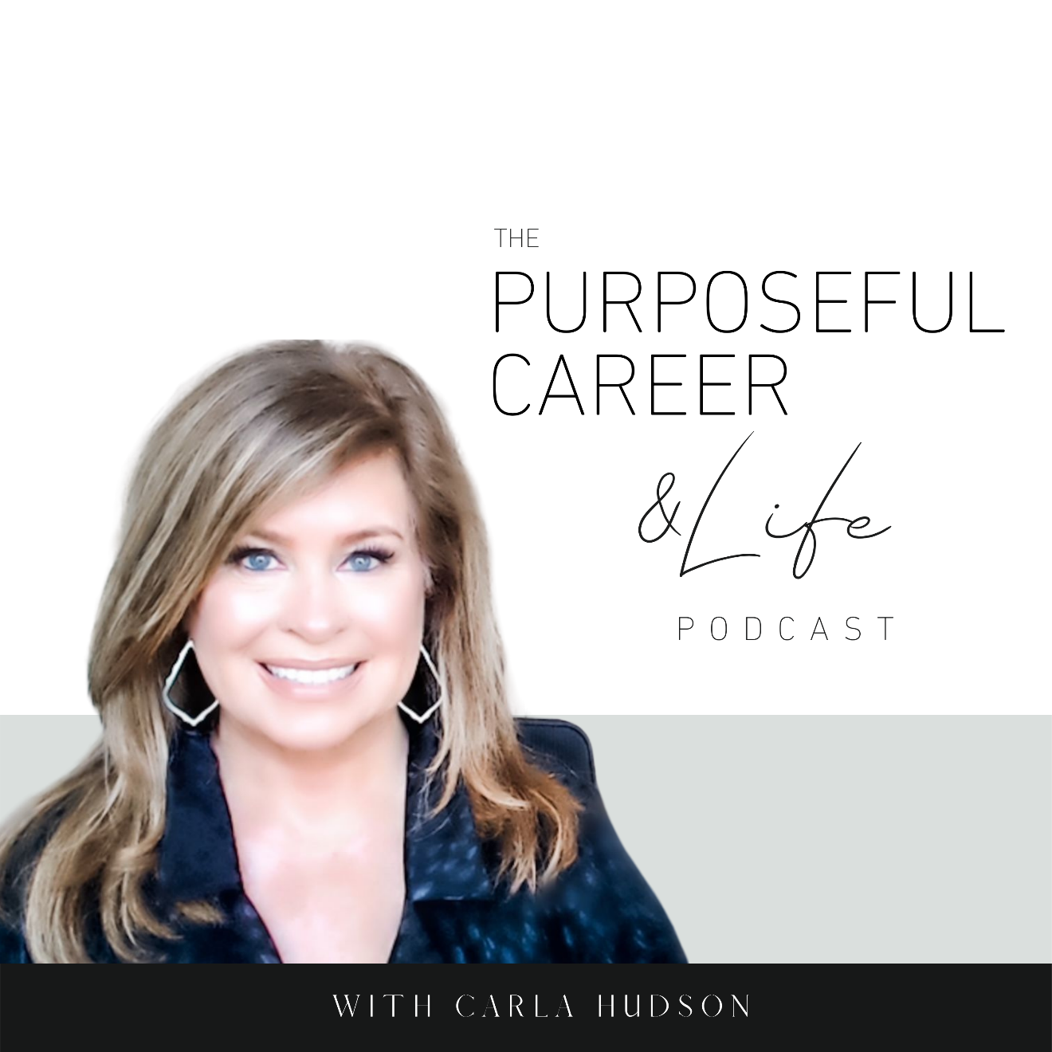

The Dark Side of Safety

February 28, 2021
Well, hello friends. I hope you had an AMAZING week.
Mine was great.
We’re about two weeks past Snowmageddon in Texas and things are starting to get back to normal. Running water though is still an issue for like a million people across the state.
I feel fortunate not to have been affected by it, but it is shocking that the state was to ill prepared.
The toll the lack of water has taken on families is very real. And I know we’re all hoping everything gets restored as quickly as possible.
As I followed the news stories on the issue this week, it led me to think about what it means to be ‘safe and secure.’
When it come to our lives and loved ones, safety is at the top of the list, right?
We want to know that no one is at risk. That everyone is okay. That we can go about our lives and not have to worry about the welfare of ourselves or those we know and love.
It feels good. Heartwarming.
But very often, the need to be SAFE has the exact opposite effect when it comes to our careers – whether we’re on the corporate or entrepreneurial track or somewhere in between.
There’s a dark side of safety when it comes to our professional lives.
Why?
Because in the context of our careers, safety usually means we’re holding ourselves back.
We’re playing small.
Not living up to our fullest potential and likely, not allowing ourselves to realize our dreams and ambitions.
I know this has been true in my own life. Especially as it comes to starting this business. But it also played a smaller role in my corporate career when it came to one specific thing, which we’ll talk about in a minute.
This need for security is something I’ve seen so many of my colleagues and clients contend with.
And that’s why today, we’re going to talk about THE DARK SIDE OF SAFETY.
So, let’s dive in.
As you know, all month we’ve been talking about our Inner Critic – that persistent negative internal talk track that runs on a continual loop for most of us.
We learned in earlier episodes how our Inner Critic is not our enemy, but our misguided friend. So, it’s important to soothe it instead of fighting it or whatever.
And we learned that our critic uses negative motivation and false control to try to get us to do what it can to keep us protected.
Today we’re going to talk about the last – and I think the most problematic or pervasive – technique the Inner Critic uses, which is all about convincing us that if we put ourselves out there or go after a big new thing, it’ll BE…A…DISASTER.
For me, this played out in one prominent way throughout my corporate career, which was around speaking in front of large groups.
I just wouldn’t do it. Period.
So, whenever an invitation came, I invented a grand excuse to get out of it.
And I did it so often and for so long that honestly, I didn’t think anything about it.
I certainly never thought about how it might be holding me back.
It was quite the opposite.
Actually, it felt like a GREAT IDEA to say no. It felt smart.
And on the rare occasion when I DID accept an invitation, I would ALMOST IMMEDIATELY be overwhelmed with fear and self-doubt.
Why?
Because my Inner Critic had flipped on a talk track that told me I’d screw up.
That I would freeze or stumble over my words.
That I didn’t KNOW ENOUGH to be up on that stage, sharing my knowledge and experience.
Basically, that I just wasn’t GOOD ENOUGH.
So, when my Inner Critic told me those things, I believed it.
After all, that voice in our head feels wise, right? And listening to it feels like something we should do.
The things our Inner Critic tells us FEEL TRUE.
Not because they ARE true, but because the voice isn’t coming from outside us. It’s coming from INSIDE.
And there’s something about the Inside the House source of it that feels profound. Like something we should listen to.
So, when I LISTENED to my inner critic when it came to public speaking, I would think thoughts like:
“I can’t do this.”
“I’m going to make a fool of myself.”
“Who am I do try to pass myself off as an expert.”
Those thoughts caused me to feel fear, uncertainty, self-doubt.
And then what did I do?
I made up my grand excuses. I invented new and highly creative ways to say no.
And as a result, I didn’t speak on stage. EVER.
Make no mistake about it…when I said no, it felt GREAT. AMAZING.
The relief that washed over me was so deep and so profound.
Best. Feeling. EVER.
But in truth, somewhere deep inside, I also felt sad.
Why?
Because I didn’t try.
Because I played small.
Because I was hiding.
Because I didn’t believe in myself.
And this, my friend, is THE DARK SIDE OF SAFETY.
When we play small and don’t go after our dreams or say no to things that should be some of our most tangible and visible milestones of success – like speaking on stage or taking that big new job – we KNOW we’re holding ourselves back.
Now our Inner Critic feels differently.
It tries to convince us that you did the smart or right thing.
That trying that new big thing is risky and that’s not a good idea.
The Inner Critic is really that primitive part of our brain that’s evolved over Millenia.
It uses a tried-and-true technique that worked so well on our caveman ancestors.
For them, leaving the cave or traveling solo meant potential becoming the Lion’s dinner.
But in modern society, putting ourselves out there doesn’t present the same risk as it did for our ancestors.
And yet, we fear it just as much.
So many of us crave the safety of anonymity while at the same time longing to realize our full potential.
Those two things are at odds.
We deeply want that big new thing. But we also want to stay safe and avoid failure.
That’s why people start trying to write that book and then never finish.
Or stay in the same job for years instead of pursuing that new career path that is calling to them.
Or why they stick with that “safe” corporate job instead of starting that business they’ve been dreaming of.
The dark side of safety is that we exchange our dreams for security.
This relegates us to a life lived less fully than it could be.
One where we watch others go after and GET their dreams while we stay right where we are.
We’re safe. But we’re not fulfilled.
We didn’t fail. But we didn’t succeed either.
We didn’t embarrass ourselves. But we also didn’t shine.
When we play it safe in this context – when it’s because the Inner Critic is trying to scare us into playing small – it can become a habit.
We almost become addicted to the certainty that the feeling of safety brings.
We don’t have to feel uncomfortable.
We don’t have to feel the disappointment of failure.
We don’t have to struggle to learn something new.
We can live in ease instead of trying hard things.
But you know what?
While it feels good to be comfortable in some areas of life, it’s not always a good thing.
For example, when it come to our dreams, I’m convinced that when appease our Inner Critic, it erodes our self-esteem.
Somewhere deep inside we begin to believe we CAN’T do that new thing.
That we really AREN’T good enough.
That we really ARE too old or too young or whatever.
That we AREN’T qualified.
And it becomes this black hole – this void – deep inside us.
That’s the place where we bury our hopes and our dreams, hoping that if they’re buried deep enough, we won’t have to think about the fact that we’re too afraid to go after them.
Sure, we allow ourselves to think about them every so often.
But if we buy into our Inner Critic’s talk track, it’s NEVER going to be from a perspective of REALLY going after them.
Does this sound familiar?
If so, you’re not alone. This affects so many of us.
So, what do you do about it?
Like we’ve been saying all month, it really comes down to four things.
- Notice the negative and judgmental thoughts your Inner Critic serves up.
- Acknowledge them in a loving way. Like “hey, I see you” or “thanks for trying to keep me safe” (because remember, our Inner Critic is really not our enemy…it’s our VERY misguided friend).
- Just firmly (but gently) put your critic in it’s place by saying “we’re going to do this another way.”
- Choose a new though that does serve you. Maybe something like “I’ve got this” or “I’m all in” or “I’m going to give this my best shot.”
These new thoughts all come from a place of confidence and determination.
There may still be some fear or uncertainty in there as your critic might keep whispering for a while, but it’s like working out.
The more you do it, the most consistent you are with purposeful directing your thoughts instead of letting your inner critic take the lead, the stronger and more confident you’ll feel when trying something big and new.
Will you succeed? Maybe.
We don’t always succeed at everything we try.
But when give that new dream everything we’ve got, even if we don’t achieve it, we get to experience something almost better.
We get to experience who we’ve become BECAUSE we believed enough in ourselves to try.
Until next week, make it a great week my friends.

