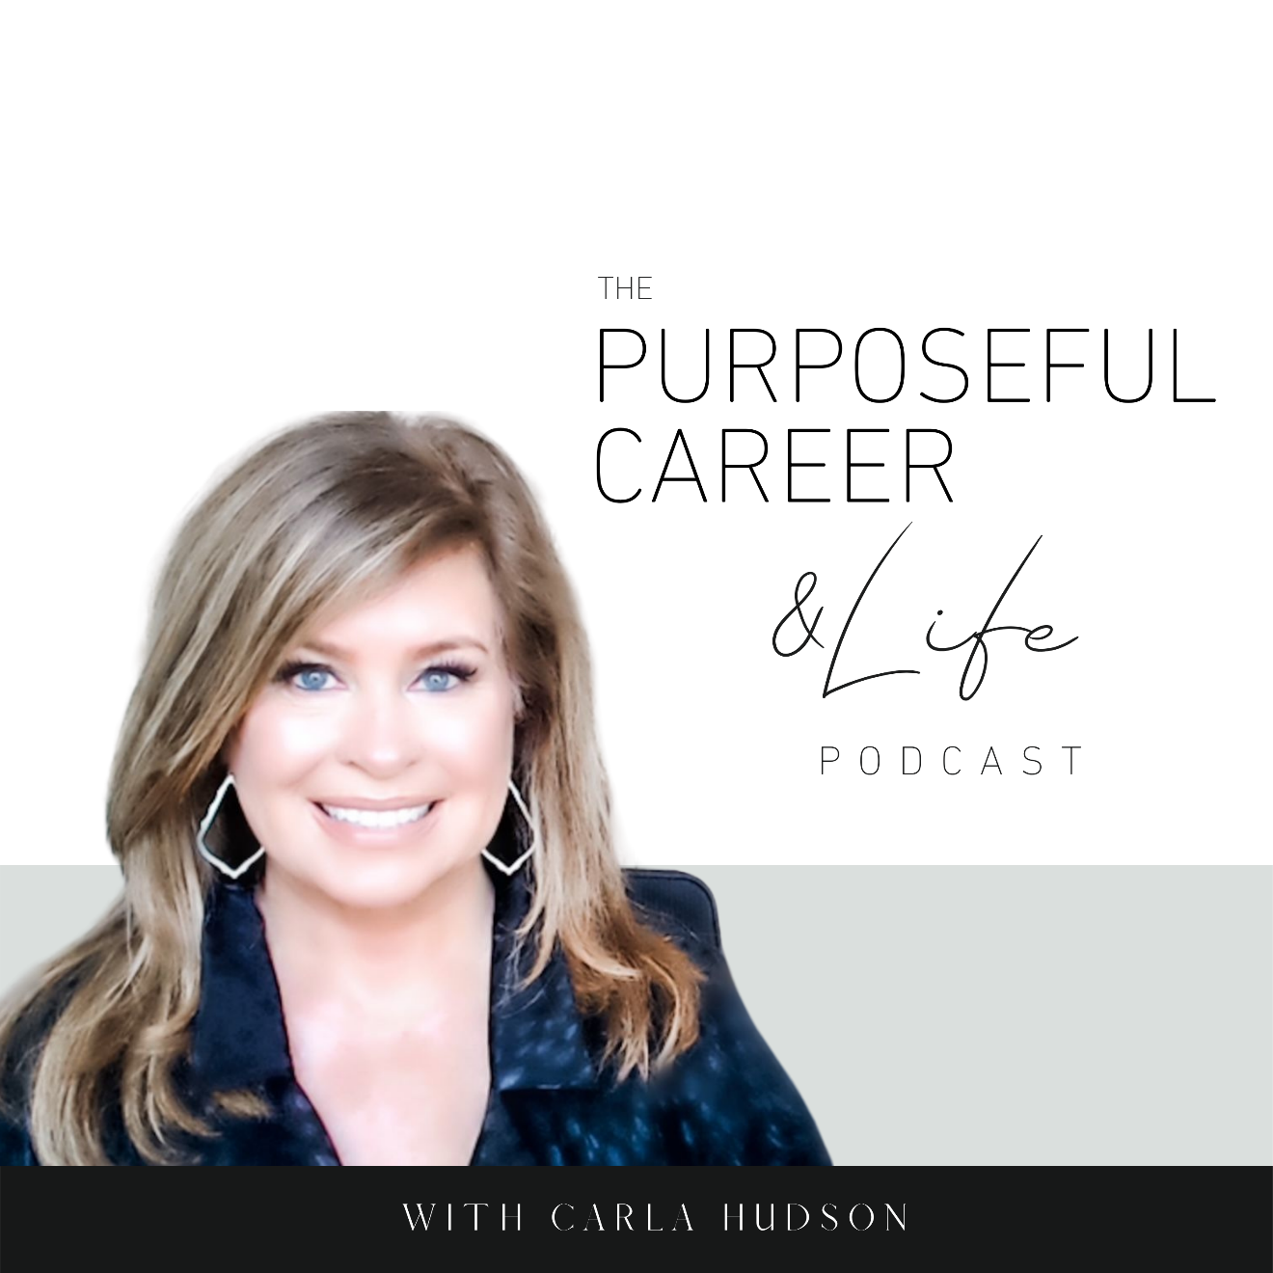

Breaking the Procrastination Cycle

March 21, 2021

Well, hello friends.
I hope you had an AMAZING week.
Mine was great.
It’s that time of year in Texas. We get like a month I think when the mornings are cool, and the weather tops out at like 70 degrees. Not too hot. Not too cold.
It’s San Diego weather – my favorite place on Earth.
Perfect.
I even took a few days off this week to do some house stuff. And I got to about half of it. So, I did good enough to feel satisfied, but I’m not gonna lie, I procrastinated on the garage stuff.
For me, the garage is not my happy place.
It’s a place to put things I don’t want to deal with.
And it’s the place I must walk to in order to get in and out of my car.
That’s about it.
And it’s not like I ran out of time. I had PLENTY of time to organize the garage.
I just didn’t do it.
Even though I promised myself I would.
So, as I was thinking about getting back into my weekly routine minus what was supposed to be a well-organized garage, it made me think about procrastination and how it shows up for all of us.
You know, it’s never really been an issue for me in my career.
If I had something to do, I would just dive in and do it. Even the unpleasant bits.
I just wanted to get all the things done on time. And I wanted to do it with as little stress as possible.
For me, it’s about Negative Motivation which we talked about in Episode #7.
I was motivated by the desire to avoid the pain of NOT doing the thing. And to avoid suffering the stress of having to do it at the last minute.
But in my personal life, it’s a little different.
I make promises to myself and I totally intend to keep them and then…I don’t.
Especially with things I don’t like…like organizing the garage.
So, because of that, every time I pull in and out this week, I’ll experience the guilt of not doing something I promised myself I would do.
Sound familiar?
Most of us procrastinate in certain areas of our life.
But if you do it on the regular in your career, it’s likely holding you back and that’s why I wanted to explore why we procrastinate, how it affects us and, more importantly, what we can do about it.
So, let’s dive in.
We all know that procrastination means “to put off doing something.”
But it’s also interesting to know that procrastination comes from the ancient Greek word “akrasia” which means “doing something against our better judgment.”
When we procrastinate in doing something, we know we’re not only avoiding the task, but that it’s probably not a great idea.
But we do it ANYWAY.
And THAT’S why procrastination does such a number on us, RIGHT?
Because when we do it, we not ONLY deal with the pain of not doing the thing we know we need to do, but we ALSO know that we procrastinated even though we KNEW it wasn’t a good idea.
That by doing so, it might cost us in some way.
So, if we know something might hurt us…why do we do it anyway?
Doing something we KNOW is going to have negative consequences isn’t logical.
So that means there must be a powerful hidden driver BEHIND the procrastination that’s making us do it.
So, what is that?
Well, in the simplest of terms, we procrastinate because of how we feel about doing the task we need to do.
As we’ve discussed in earlier episodes, everything we do (or don’t do in this case) comes from how we feel. The emotions we experience motivate our actions.
So, when we procrastinate, we’re likely feeling something like boredom, anxiety, insecurity, frustration, resentment, overwhelm or self-doubt. Things like that.
And most of us believe that we feel that way BECAUSE of that thing you need to do.
But that’s NOT the reason.
The reason you have those feelings like boredom, anxiety or overwhelm is because of what you’re THINKING about that thing you need to do.
And those emotions are what is causing you to take the IN-action of procrastination.
So, you are choosing to NOT do the task you think is causing you to feel those negative emotions because you are trying to DELAY having to experience those emotions.
And notice what you are probably doing INSTEAD of doing that thing.
Because usually It’s something SUPER indulgent.
Like maybe scrolling your social feed, bingeing on Netflix, browsing Amazon, going out with friends or whatever.
In my practice, we call this buffering.
Because it’s about doing things to soothe yourself or to avoid having to experience emotions that we don’t want to experience.
So, let’s play out an example of how procrastination sometimes looks in our career.
Let’s say you have a presentation to prepare for work.
You know the deadline, you know the topic, but maybe you don’t feel you have all the information or maybe the idea of it just bores you.
So, you just can’t make yourself get started.
Maybe you’ve tried to dive in a few times, but then you just sit there in front of your computer with that blinking cursor, and you might be thinking something like “I don’t know where to start” or “I don’t have all the information I need” or “What if I do a bad job?”
Any of those thoughts could cause the self-doubt, anxiety or insecurity that might cause you switch from that presentation to the latest episode of Bridgerton.
And it DOES feel good to watch that favorite Netflix series or eat that leftover cupcake.
Some of us might even try to justify our actions by doing something we try to tell ourself is “productive” like organizing our drawers or whatever.
And we’ll say, see? I was STILL productive.
Like we’re trying to justify not doing the thing we NEED to do by instead pointing to the thing we CHOSE to do as the reason putting it off was a good idea.
And when we put off doing the task that’s linked to those negative emotions, we DO get some relief.
For sure.
Because chances are the things we’re doing INSTEAD of doing the thing we know we NEED to do but don’t really WANT to do FEELS better.
But here’s the truth about procrastination.
It takes the thing we already link to negative emotions and doubles down on the negative.
How?
Because our brain KNOWS the deadline is still there. It’s not moving.
So now you’ve got this ticking time bomb in your brain and every hour you delay doing that thing you don’t want to do, your stress and anxiety and self-blame INCREASES.
This amplifies the stress for sure.
But it also creates a secondary non virtuous thought loop in your mind about how “you can’t trust yourself” or you’ll label yourself “a procrastinator.”
And worse, if you DO manage to get the thing done on time and it’s reasonably good, you’ve now created yet ANOTHER non-virtuous cycle in which you believe that you do better under pressure.
I honestly can’t count the number of clients who’ve said this to me.
“I’m better when I have less time.”
“I always work better under pressure.”
And they BELIEVE it.
They think it’s okay.
But what they’re ignoring is the price they’re really paying BECAUSE of that belief.
Because chronic procrastination has long-term effects on our mental health and the quality of our life.
By always waiting until the eleventh hour, we experience things like chronic stress, depression, anxiety, overwhelm, poor self-care, even chronic illness.
So, while avoiding the thing you dread might help you avoid negative feelings in the short term, in the LONG TERM, you’ll pay a bigger price.
Some people will think this is just about self-control. They’re say “well, I just need to be more disciplined.”
And others will think the answer lies in making better use of our time. So, they might search for productivity hacks or whatever.
But those things only address the symptoms of the issue. They won’t work to change your procrastinating behavior over the long term.
To do that, you must disrupt the cycle of pain and pleasure.
The best way to do that with procrastination is to shift your focus from the pain/pleasure of Today You to the pain/pleasure of Future You.
Here’s what I mean.
The procrastination cycles we’ve outlined in this podcast are caused by something psychologists refer to as “Present Bias”.
That happens when we give a stronger weight to rewards that are closer to NOW vs. rewards that happen in the Future.
For humans, this tendency is hard-wired in.
Psychologists say it’s really about our primitive brain.
Our caveman ancestors weren’t going to survive by thinking ahead into the future because they needed to focus on providing for themselves in the here and now.
Because of evolution, our primitive brain is still alive and well.
And in the case of procrastination, the primitive brain wants to avoid pain and get more pleasure. This can keep us stuck in those non virtuous cycles we discussed.
So, what’s the answer?
Well, first you need the self-awareness to know that procrastination is a thing for you and that it’s NOT serving you.
Second, use a tool I call Now and Later.
This directly counterbalances all of the things about procrastination that don’t work for you.
Here’s how it works.
When you’re faced with doing something unpleasant and you know it’s something you’d typically procrastinate on, instead, choose a thought like “I’m going to spend an hour on this to get started and I’ll finish it up later.”
This approach takes the pressure off in two ways.
First, by starting the thing now you’re alleviating the pressure and stress you would encounter by having to do it at the last minutes.
Second, by not putting the pressure on yourself to do the WHOLE THING now, you take the unpleasantness away. You only need to get it PARTIALLY DONE right now, which won’t take as long and it doesn’t have to be perfect.
Like maybe you just do the outline for the deck.
Or the FIRST DRAFT of the report.
And if you’re missing information, just leave a placeholder pages blank and you can fill those in later.
The benefit here is the pressure is off. This is just the first draft. That’s all.
Give yourself a time limit. Tell yourself it’ll only take an hour or so.
And then give yourself another little reward like going to your favorite place for lunch. Or maybe taking Friday afternoon off.
Then come back to the thing in a day or two and finish it up.
This ALWAYS worked for me in my corporate career.
If I had an unpleasant thing I needed to do, I would tell myself that if I started it NOW, I could have the pressure off for the rest of the week. Or weekend.
So, I’d start on it right away. Even if it was something I didn’t want to do. Even if I only had a third of the information I needed.
I’d do a very rough draft – maybe spend an hour or two on it.
Then I’d put it aside and reward myself by doing something I REALLY wanted to do in the short-term.
Like watching Bridgerton or re-watching Grace and Frankie (I LOVE that show).
But only AFTER I got the first draft done.
Then when I came back to the thing to finish it a few days later, I was usually surprised that it was in pretty good shape.
And it was pretty quick work to make some edits or additions, tweak it and it was done. Sometimes even ahead of schedule.
And I got to be relaxed.
And I didn’t have to give up my nights and weekends.
And I always delivered on time.
So, I got both the short-term reward of Netflixing but I also got the long-term benefit of having less stress, less imposition on my off time and I got the satisfaction of knowing that what I turned in was my best effort.
This always works. Always.
And it’s a good reminder to me of my garage.
As soon as I finish recording, I’m going to go out there and spend an hour on it. And then I’ll come back and finish it later.
That way, I don’t have to start the work week knowing I didn’t do the thing I promised myself I’d do.
It’s a concept I call Now and Later.
When something is unpleasant, don’t put it off.
Do a little bit now.
Enjoy a little reward.
And finish it up a few days later.
No stress. No overwhelm. No anxiety.
It works. Every time.
Make it a great week my friends.

