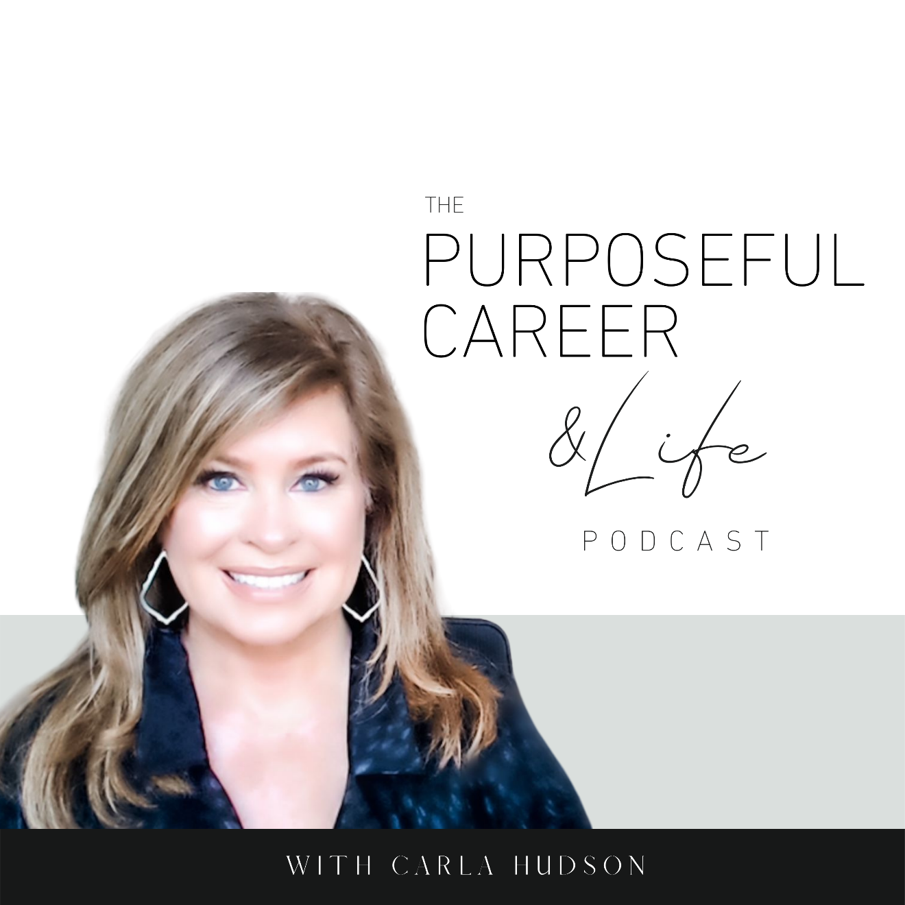

Creating Future You

May 2, 2021
Hello friends.
I hope you had an amazing week.
Mine was so great because I was SUPER productive, not only with work but at home. It was one of those weeks where I tackled some of those not so fun things like cleaning out a few closets.
You know…the ones you rarely venture into except when you want to stash something away.
I literally pulled everything out, went through every box and did the keep, toss, donate thing. And then took the time to figure out how to put it together in a smart way.
Like with storage containers that match. And organizers that efficiently keep things neat but still in sight.
Now when I look at the closet, it not only LOOKS good, but it also FEELS good to look at it. I feel like it was put together JUST FOR ME.
I usually don’t do this. Sure, I’ll clean out the closet and toss things. But usually, I just put the stuff I keep right back in the same containers and put it all away.
But not this time.
This time I took the time to plan out, in advance, what I wanted it to look like. What features and functionality I needed it to have.
So, by the time I got done with the closet cleaning, I had not only a cleaner closet, but one that was perfectly aligned with what I needed and wanted it to be.
And that made me think about the message for this episode.
As you know, last week we finished our Getting Unstuck series. Five episodes that dive deep into what causes us to get stuck and some strategies for breaking free and moving forward.
In last week’s episode we explored Fear of Success, a topic I think we don’t hear enough about because I know it holds so many of us back. Deeply rooted in this concept is the fear of letting go of who were used to be in favor of who we want to become.
And that gap between past us and future us can be huge and I think too many of us leave it up to chance. This week, we’re going to talk about how to create future you. On purpose.
So, let’s dive in.
As humans, we’re trained to look at our past for answers and for a mirror to reflect who we are or how we see ourselves in our present.
So, in our career, we tend to examine our past mistakes and celebrate our past successes. And it’s the combination of those two things that, for most of us, shapes our self-concept.
Most of us are actively involved with our past selves.
But we view the future differently. And I believe, much more passively.
For some of us, the future is something to look forward to with excitement or anticipation.
For others, the future is something to be feared because it involves the UNKNOWN (which we talked about in Episode 14, so check that out if you haven’t already).
One of the things most of us have in common is that when it comes to the FUTURE, we will set goals or have dreams or mark plans for things we want to do have or experience.
But very few of us will ever take the time to think about WHO WE WANT TO BE or who we will need to be to LIVE IT.
Right now, I’m coaching an executive in corporate America who’s experiencing significant vertical growth.
She’s proud of what she’s achieved but is trying to reconcile this amazing new level of success – the big title, salary, and prestige - she just achieved with her concept of herself.
She often finds herself feeling uncomfortable.
She finds feeling awkward or inauthentic.
It doesn’t make sense on the surface because she’s got all the skills. She earned that level of success.
So, what’s the problem for her?
Well, for starters., she’s always used her past experiences and successes as a mirror for who she is. And that worked okay up till now because her progression followed a linear path.
She moved forward one step or progressed one natural level at a time. So the growth and shifts she made were more natural or gradual and so relying on the past as a mirror for herself was believable.
But now she finds herself in a new company in a role where she’s running the whole function. Where her team is a few hundred people and growing. Where success or failure – not just of the team but of the entire department and perhaps the company – is on her shoulders.
She’s just experience quantum growth. There’s nothing to look back to in order to reflect who she is now. She’s creating it REAL TIME.
So, we’re working on creating Next Level Her.
Which I’ll tell you more about in a minute.
I created this exercise for people experiencing quantum growth like my client is experiencing.
Or people make the shift from function to another.
Or people moving from corporate employee to entrepreneur.
Or suddenly gaining national visibility or global prominence within your field.
But honestly, it’s for everyone.
Why?
Because I think we have it all out of order.
Instead of thinking about what we want to DO, HAVE or BE in the future, we would be better served by FIRST thinking of WHO WE WANT TO BECOME in the future.
And here, I think it’s helpful to still use a mirror concept, but instead of looking to the past as we do now, we imagine ourselves 3-5 years from now.
So, here’s the exercise:
We step into that energy. Imagine being THAT person. And then, looking at that Next Level version of ourselves through the eyes of others.
Why? Because it’s usually easier to look at ourselves in a more detached way when envisioning how we want others to see us vs. how we see ourselves. Because most of us have that nonstop Inner Critic. But this outside in way of creating Future You sidesteps the inner critic so you can really examine the possibilities.
Once you’re imagining yourself 3-5 years from now, take out a pen and paper and write down the answers to the following questions:
- What kind of leader do my employees think I am?
- How do peers in my company or industry, think of me?
- What special skills set me apart from others in my company or industry?
- What image do I project with my appearance?
- What do I believe about myself based on the success I’ve created?
- What’s most important to me about my career and life NOW and how do I honor that?
Back to the executive I’m coaching. She’s now answered the questions above.
Now we’re working on using those answers – based on her Future Next Level Self – to bridge the gap between her present self-concept and the NEW one she’s choosing to create.
This is going to help her shift from feeling awkward, uncomfortable, and inauthentic to confident, focused, and Authentic as quickly as possible.
So, whether you’re currently in the middle of something new or just dreaming of it, I encourage you to START with creating a compelling vision of FUTURE YOU.
And from THAT energy, you can create the next level goals that FUTURE YOU is capable of carrying out.
Think for a moment about the difference.
Today, we tend to use our past successes to create our current view of ourselves and that current view is what we use to create future goals.
So really, our past self is what we’re relying on to shape the BIG things we want to go do.
And we wonder why we get stuck.
Or beat ourselves up by telling ourself what we want is impossible.
A BIG next level future would naturally look impossible when viewed through the lens of the you or five or ten years ago (or whenever your last big success was).
But if you intentionally shaped Future You FIRST. And if you used THAT version of you to set those goals, imagine how much easier it would be.
How much more believable.
Maybe even how much faster.
And when you actually GET those new things.
Imagine feeling COMFORTABLE. AUTHENTIC. AT EASE.
Because you’re not LEARNING to step into next level you.
You’ve just FINALLY caught up to the you that you already decided to become.
This is the exercise I developed when I was making the shift to entrepreneur. And after years of stops and starts, when I intentionally shaped Entrepreneur Carla, that’s when I finally started moving.
This is the energy from which even BIGGER things are possible. Things the today version of you might find too scary or unbelievable to dream of.
They’re all possible. It’s just a matter of who you choose to become.
You can shape it. Starting today.
Future You is waiting.
Let’s see what’s possible.
Until next time, make it a great week my friends.

