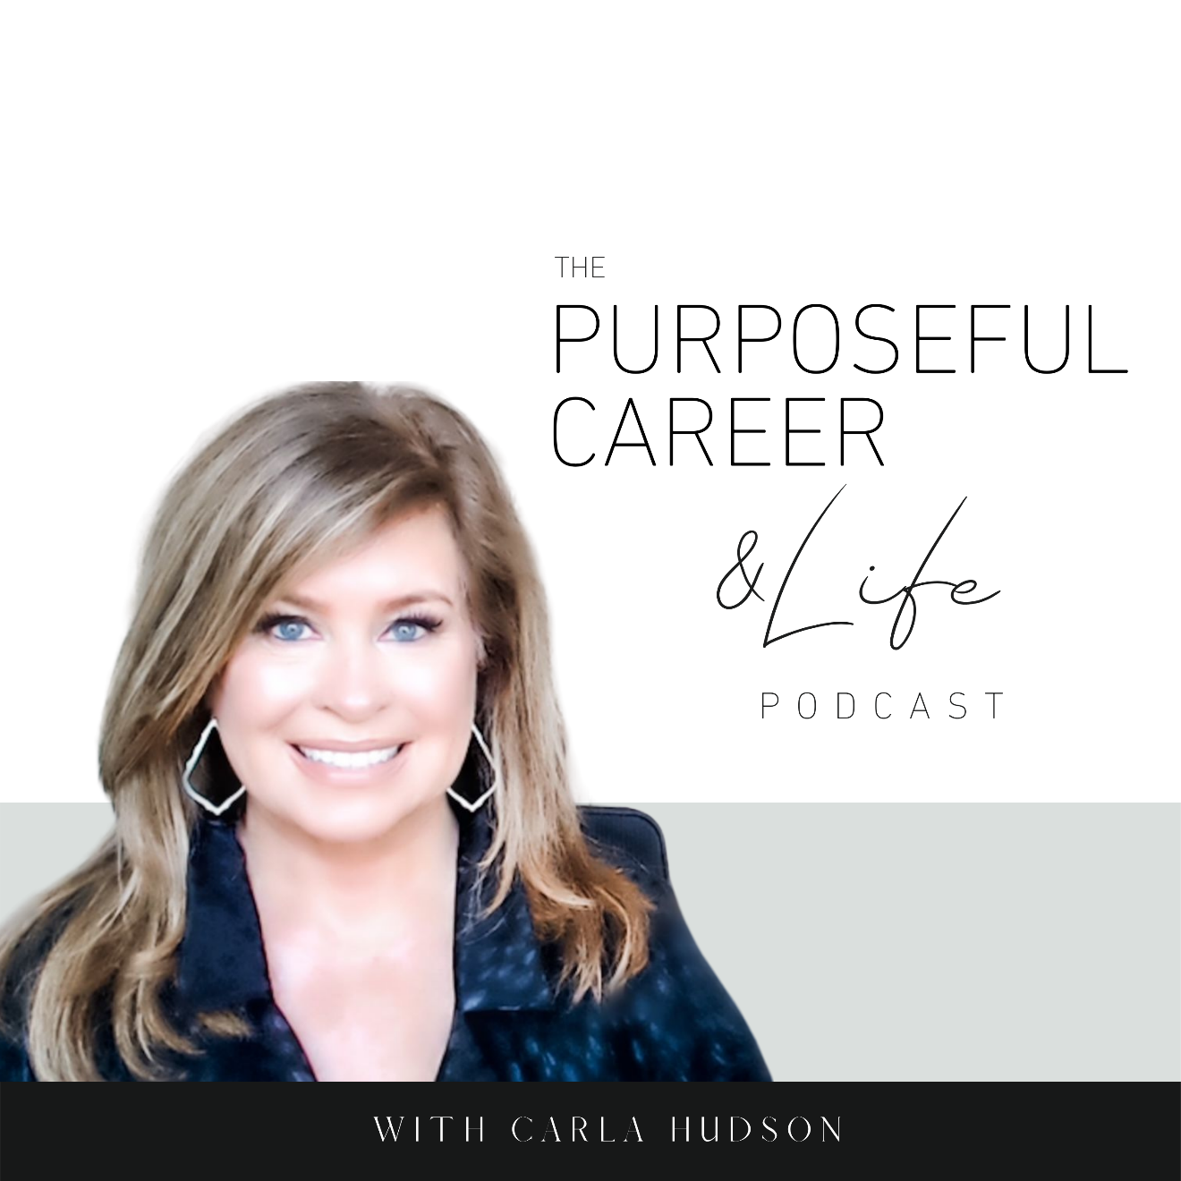

Why You Quit Things

May 23, 2021
Well hello friends.
I hope you guys had an amazing week.
Today I want to talk about Why We Quit Things.
Or maybe more specifically, Why We Quit on Ourselves.
Most of us do this in one way or another. And it’s never a great thing. But for many it becomes a pattern that holds them back.
You know what I mean.
We start the diet determined to head into swimsuit season at our ideal weight. So, we start the diet determined and motivated. And then a few weeks or a month in, we give up.
We decide this is the year to find the ideal job. So, we dive into the job search with gusto, land some interviews and when the rejections start rolling in, we give up.
We start the direct sales business or other side hustle and go all in. At first. But when it gets challenging finding clients or managing the calendar, we decide it’s not meant for us; it’s too hard, so we give up.
And there’s lots more where that came from in every area of our life – with relationships, paying off debt, working out, starting the business, changing career paths.
Too often, we give up.
I wanted to talk about this today because I see it all the time in my practices.
I’ve done it too often in my own life.
The diets I’ve started and stopped.
My passion for writing romantic fiction which I just gave up after finishing a few books.
Even my efforts at getting this business going. I’ve started and stopped many times.
So, are you quitting on anything?
If so, what?
It’s important to remember when we quit something we really want, we’re not just quitting that thing. We’re quitting ourselves.
And that’s why I wanted to talk about this topic today. Your goals and dreams and YOU are too important to quit on. Today we’re going to explore the whys and learn what we can do about it.
So, let’s dive in.
When we set a big goal or have a burning desire to do something, it feels AMAZING.
We see the vision, imagine how amazing it will be to HAVE the new thing.
This DESIRE gives us the motivation and excitement to get going. To START the thing believing that we can HAVE it.
So, we fix our eyes firmly on the horizon and start moving forward.
Then we get into it.
And as we go, the days and months and sometimes years tick by and we start to encounter challenges.
Obstacles.
Rejection.
Challenges.
Setbacks.
And that’s when a shift starts to happen.
Suddenly we don’t FEEL motivated or excited.
And maybe we can’t even connect with our DESIRE for the thing anymore.
We just know we suddenly feel discouraged.
Uncomfortable.
Bored.
Defeated.
Because it no longer FEELS good, our discipline or pursuit of the DREAM starts to slip.
After all, who wants to throw all their energy and effort into something that DOESN’T FEEL GOOD?
And if these negative emotions PERSIST, we quit.
For most of us, when we quit, we’re rewarded – at least for a little while – with HUGE feeling of relief.
The discomfort, boredom and feelings of defeat are gone because your life can go back to NORMAL.
We tell ourselves NORMAL is okay. We’re used to it. (Even though our life might not be what we want, it’s what we’re used to and that’s okay).
And because we FEEL better, we tell ourselves it was GOOD that we quit.
That the thing we were pursing wasn’t meant for us anyway.
The problem though is that when this pattern of quitting on yourself becomes ingrained, it erodes our belief in ourselves.
We start to believe we CAN’T do the things we dream of.
That we’re not GOOD ENOUGH.
That it’s pointless to EVEN TRY.
That we can NEVER DO HARD THINGS.
What we just DON’T HAVE WHAT IT TAKES.
Sound familiar?
If so, you’re not alone.
Most of us struggle with this in one way or another.
It’s one of the reasons so many of us settle for a life or career that is so much less than we dream of.
We stop believing we’re CAPABLE of having or being some next level version of ourselves.
We think we can’t do it.
But the truth is, the problem isn’t YOU it’s your BRAIN.
Specifically, it’s what happens when we let our brain run the show instead of living consciously.
What I mean is that the problem if not that you feel uncomfortable or bored or defeated when you’re experiencing a challenge or a rejection or a setback.
The problem is what your BRAIN is making that mean.
As we’ve talked about before on this podcast, our brain is like a really powerful supercomputer.
Neuroscientists say we have about 60,000 thoughts a day.
Whatever the number, there are so many thoughts whizzing by everyday we’re not aware of most of them.
And in addition to the volume of thoughts, we also have a brain that (to keep up the computer analogy) has a lot of RAM.
So, when we experience things in our life – either good or bad – our brain will not only assign a meaning to them, but it will store them away.
We’re not even aware of this.
But in the future, when we experience something similar, our brain will retrieve that old thought that was filed away on our hard drive and it’ll serve it up.
And again, it’ll likely be a thought we’re not even aware of having.
We just know we are feeling all these negative emotions.
And when we feel those negative emotions, we take an action that doesn’t serve us. We quit.
It’s a non-virtuous and probably unconscious thought loop in your mind where an old self-limiting thought causes you to feel a negative emotion which inspires you to take an unproductive action (quitting), and what happens?
We don’t get the THING we wanted.
When it comes to this idea of quitting it’s important to know that we will likely always have times when the IDEA of quitting pops up.
It’s part of being human.
The truth is, we humans don’t like to be uncomfortable, discouraged or rejected.
We like the GOOD feelings of excitement and motivation that come with pursuing our dreams, but we’ll do almost anything to turn off the downside.
Now that we understand why we quit, you might be wondering how we can stop.
Or even whether we can stop.
After all, if our brain is storing things away and pulling them back out in our subconscious, what can we do about it?
The answer is…there’s A LOT we can do about it.
It starts with having awareness into what gets in YOUR way. Because we all have our versions of why we quit.
So for this, I want you to think about a time when you REALLY wanted something.
Maybe it was a new job.
Or a change of career.
Or going back to school.
Or losing weight.
Or a new relationship.
Whatever it is, come up with something specific because we’re going to do a little exercise.
I want you to think about that thing you quit and I’m going to ask you six questions. These questions will help you understand the type of quitting pattern you have.
- Did you want the outcome (the dream) MORE than you want the skills and experience you’ll gain by pursuing it?
There’s nothing wrong with focusing on the dream you want. After all, that’s inspiring and can help you keep going. But with most dreams there’s a lot of things you’ll need to do in order to have it. It’s helpful to keep the perspective that it’s NOT just about having the thing, it’s about WHO YOU’RE BECOMING because you’re pursuing it.
Focus on what you’re learning, the skills you’re building, the experiences that are making you stronger, the pounds you have lost, the muscles you’re building whatever. Basically, learn to value TODAY just as much as you value THE OUTCOME YOU’RE SEEKING.

- Did you self-sabotage to avoid rejection or judgment.
When we put ourselves out there to pursue something big, it can bring up our fears around rejection or judgment or failure. It’s kind of like we give our world a front row seat to witness our pursuit of the thing we might never get. And that makes us feel fearful.
So if this is a thing for us, when we quit we tell ourselves that it’s not really FAILURE because we quit. It stepped on purpose. And so, we have the time to prepare for it. To make up a great story or reason that it wasn’t your fault.
Here it’s important to remember that when you quit for this reason, you’re just CHOOSING to fail in advance. And it’s because you’re no longer focusing on what you want and who you’re becoming by pursuing it, you’re focusing on what OTHERS WILL THINK. This is never useful. You can solve it by shifting your focus back to yourself. And if you want to dive deeper into this, go back and listen to The Getting Unstuck series, episodes 13 – 17. Well worth the listen and full of advice on how to move past these fears.

- Did you frame challenges or obstacles as failures?
It’s important to know that when you pursue something new and big, you will face challenges. Setbacks. Obstacles. We all do. But the key is how you FRAME THEM. What you’re making them mean. It’s as simple as deciding in advance that you’ll have some highs and lows but choose to see them ALL as lessons. While it might sound cliché it’s true. Everything we experience has something to teach us if we have the discipline to look for the lesson.

- Did you stay on your original plan vs. giving yourself permission to pivot?
Are you so attached to your original goal or plan that you stay glued to your path instead of giving yourself permission to adjust? Whenever you try something new, you learn. And those lessons might provide NEW information that would alter your original plan. Maybe even evolve your DREAM. It’s important to be flexible. To give yourself permission to pivot. And to not make that a bad thing.

- Did you want it to be easy or effortless?
We all like things to be easy. And sometimes the things we pursue WILL BE. But many times, they won’t. So, we can’t let the fact that it’s HARD mean we CAN’T DO IT. Or IT’S IMPOSSIBLE. Just because we might have to run at something a few times (or even more than a few) doesn’t mean it’s beyond us. And with each attempt, you’re learning something that will make future things easier down the road.

- Did you compare your messy middle to someone else’s fabulous end?
Some of us suffer from Compare Dispair. Meaning, we compare where we’re at with someone else who already has that thing. And it makes us feel bad, like it’s hopeless. But the truth is, you’re comparing your MESSY MIDDLE with someone else’s FABULOUS END. It’s okay to look to others for inspiration, but don’t compare your life or your situation to anyone else’s. It’s just not helpful and it can hold you back.

Now that you know your quitting patterns, here’s how to use that information.
- It starts with awareness. Now you know the things that cause you to quit. And with that information you can now do some important things.
- Get ready for next time. Know that when you have a new goal or try something new, you are very likely to have the same type of thought pattern. So prepare in advance. Choose some thoughts you can pull out the next time you feel that urge to quit. These thoughts should be something that pushes against your pattern and inspires you to stay with that dream.
- When you are pursuing something new, commit to practicing these thoughts daily. Journal. Do affirmations.
- Lastly, when pursuing something new, stay aware. Do not default to the unconscious where we let our brain run the show. A good way to do this is by staying in touch with how you’re feeling. If you’re feeling bored, unmotivated, defeated, discouraged or something like it, you’ll know you’re experiencing your brain’s familiar pattern. Intentionally pull out and affirm the new thoughts you chose. By building this muscle you’re strengthening a new, powerful neural pathway that serves you and weakening the old neural pathway that doesn’t.
Bottom line, know that at time, we all fantasize about quitting. So don’t make yourself wrong or bad or weak if this is a thing for you.
Now that you know WHY you do it and HOW you can stop, you’re literally ready for anything.
So, I’ll leave you with a final and I think absolutely fabulous question.
Now what?
Get out there and make it happen.
Until next time, make it a great week my friends.

