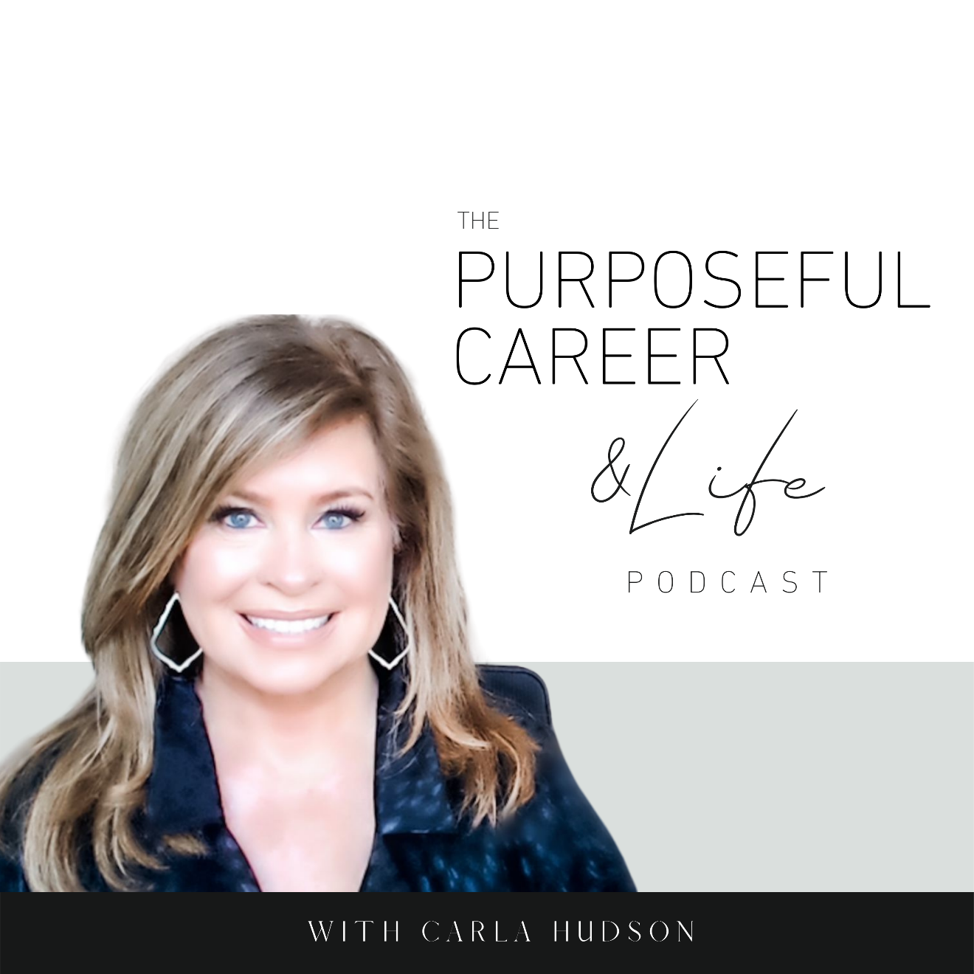

Bouncing Back

July 11, 2021
Hello friends.
I hope you had an amazing week!
Before we dive into today’ episode, I wanted to share something new I’m adding to the podcast. I’ve had so many of you send me emails or DM’s, that I’ve decided to add an Ask Carla bonus episode the last Wednesday of the month. We’ll try it out and see how it goes; see if you guys like it.
As you know, I focus on helping people who are on the corporate track or, who are interested in starting a side hustle or business. So, if there’s something you’re struggling with in your career or in starting a side hustle – a big decision, a difficult relationship, feeling stuck, whatever – you can send your question to carla@thepurposefulcareer.com. Or you can DM me on Instagram or Facebook.
I’ll pick a few questions to answer on the show.
It’ll be anonymous, so I’ll only use your first name and no location. And I’ll also try to respond personally via email or DM to each one I receive. So even if I don’t answer it on the podcast, I’d love to help you out through a private communication.
I think it’ll be an interesting addition to the podcast and if you like it, we’ll keep doing it!
So, send in your questions over the next week so I can pick a few and record the first bonus episode which will air on Wednesday July 28th. So that’s carla@thepurposefulcareer.com.
SO…last week we talked about Managing Disappointment. This is a super important skill to cultivate in your career and life. Because we all face ups and downs. And it’s how we manage the downs that make the difference between staying hopeful and possibility oriented or sinking into disbelief and low self-confidence.
If you haven’t listened to episode 27 on Managing Disappointment, you might want to give that a listen first. In that, we share that the key to managing disappointment is to shift your focus from the disappointment to a learning experience. And we offer some ways to do that. It’s worth a listen because if there’s one thing a career is chock full of, it’s opportunities to manage disappointment.
And I thought an important follow-on to last week’s episode was to discuss Resilience, which is a fancy way of saying being great at bouncing back.
So, let’s dive in.
In the simplest of terms, Resilience is the ability to overcome negative events. According to a study at Ohio State University, more than 80% of us believe we have high levels of emotional and mental resilience, but when tested, less than 60% of us score high for resilience.
After the year we’ve all had with Covid, people getting sick and dying, all of us getting thrown into remote work, some of us losing our jobs, children out of school, parents in the role of teacher, all of us feeling isolated from family, friends, and social situations. Well, it’s been a little much, right?
And while the world is still facing the headwinds of the virus, we’re starting to get back to the business of life. We’re returning to work. Kids are returning to the classrooms. People out of work are finding jobs. It’s great to see.
The world is bouncing back.
So, have you stopped to think about how well you managed through Covid and its aftermath?
Or think about other things – big and small – that have happened in your career or life. How well do you bounce back? Does it take you awhile? Do you stay stuck in defeat and disappointment, or do you spring back in short order?
Many of us believe that people are either resilient or we’re not. But that’s not true.
Resilience isn’t something we’re born with. It’s something we cultivate. Something we can build.
So let’s look at what’s underneath resilience.
Resilient people are good at regulating their emotions and staying calm under pressure. This helps to keep their head clear which leads to better problem-solving.
So how do you get good at regulating your emotions?
By mastering the art of self-control. This means, the ability to manage impulses, emotions, and behaviors so they work to your advantage vs. hold you back.
As humans, our ability to do that is found in the pre-frontal cortex. This is the part of the brain that’s highly developed in humans. It lets people plan and evaluate vs. just respond to impulse (which is caused by the Reptilian Brain.
Self-control is about taking power over your own actions and learning to ignore the urges or immediate impulses to just react. No matter how powerful they might be.
This self-control gives you the ability to direct your thoughts, emotions, and behaviors toward your desired outcome vs. just responding impulsively in a way that might make you feel better in the short-term, but which might lead to outcomes you don’t want.
Our career (and our live for that matter) is full of opportunities to exercise our self-control and will power.
Like how you respond to that colleague who’s always difficult and not supportive in meetings. Do you fire back with a zinger? Or do you keep your composure buy exercising self-control?
Or, how you respond to that email that put you on the defensive. Do you fire off an emotional response that you’ll later regret? Or do you exercise self-control and delay responding until you can do so in a calm, rational way?
Or, how you respond to difficult feedback from a boss or client or colleague.
Or even in your personal relationships. Do you say things to friends, family, kids of spouse and then regret it?
Karen Reivich, a professor at the University of Pennsylvania, has done a lot of pioneering work on the study of Resilience. If you’re interested in learning more, you can check out her book “The Resilience Factor”, which is a super interesting read and explores the 7 Factors of building resilience.
But today, I want to share with you an approach she came up with called the “ABC Model”. This is a cognitive behavioral technique that helps us understand the interplay between adversity, beliefs, and consequences.
Here’s how it works.
Step A – This stands for Adversity
Identify what she calls your “push-button adversities” or challenges. Write them down. Think of these as either situations or things people say that trigger you. These can be things in your job, your business, your relationships, social media. Anything. What pushes your buttons? In my view, a great way to think about this is ‘what kinds of things cause an immediate spike in more negative emotions’ like frustration, fear, defensiveness, anger, impatience? That’s when you know you have identified the real triggers for YOU.

Step B– This stands for Beliefs
Once you have those written down, for each one you captured, think about a time when that has happened recently. Now, identify what you say to yourself in the heat of the moment (while it’s happening). Write down the thoughts. Any of you who have listened to this podcast know that our approach to coaching is based on the cognitive behavior approach. And so, we teach that “beliefs” are just thoughts we have over and over and over again. So this piece is especially important. Becoming aware of the thoughts you have when the “adversity” or “triggering event” happens is the key to the whole thing because it’s those THOUGHTS that are causing you to feel triggered. Not the event itself.
Step C – This stands for Consequences
Now look at how the thoughts you’ve identified for each of your triggers, lead to the emotions you feel. And then play that out through your typical reaction and what that leads to in terms of a result.
According to Reivich, the key is looking at the interplay between B and C (or beliefs/thoughts) and consequences. Because as we teach in our coaching practice, it’s our thinking that always determines how we feel, what we do and the results we get in our lives.
We teach the Self Coaching Model, which we outline in Episode 1, the five interrelated parts of any problem. But it’s further validated by Reivich’s ABC model.
Bottom line, it’s important to know that your negative feelings or your triggers don’t come from the things people say or do. They come FROM what you THINK about what people say or do.
So if you want to get great at bouncing back, you must get great at being intentional with the thoughts you choose to have.
And what I really LOVE about Reivich’s ABC model is that it starts with the “trigger” or what pushes your buttons. This is really great way to identify events or situations where you have a heightened emotional response. One you don’t want to have.
That’s when you KNOW that behind that emotional response is a thought or series of thoughts maybe that actually CAUSED that emotion.
See, we don’t think that’s the way it works.
We are trained to think that we FEEL the way we do because of the situation or event. But it’s NEVER the event that caused it. It’s how WE think about it or what we make it mean about us, about that person or whatever.
And connecting into the extreme emotions is a great way of knowing that this is an area where you need to click into the thoughts BEHIND that emotion, examine them and identify how they’re playing out in your actions and results in ways you might not want.
And by choosing a different thought, you have the power to completely shift your emotions.
Think of the biggest triggers in your life.
That argument you have with your kids or mother or spouse over and over again.
That person at work who bothers you.
That thing your boss always says that instantly triggers you.
Or whatever.
Now imagine a world where that SAME thing can happen, and you’re NOT triggered.
Where you feel neutral.
Where you just move on with your day instead of wallow in frustration or anger or defensiveness.
That’s a better world, right?
When you choose to build resilience, that world is available to you. Immediately. You just have to do the work.
Give the ABC Model a try.
Or check out episode 1 on the Five Interrelated Parts to any problem.
They are different ways of getting at the same thing.
Most importantly just know that YOU can create the resilience – or anything else you want – right here. And right now.
Until next time, make it a great week my friends.

