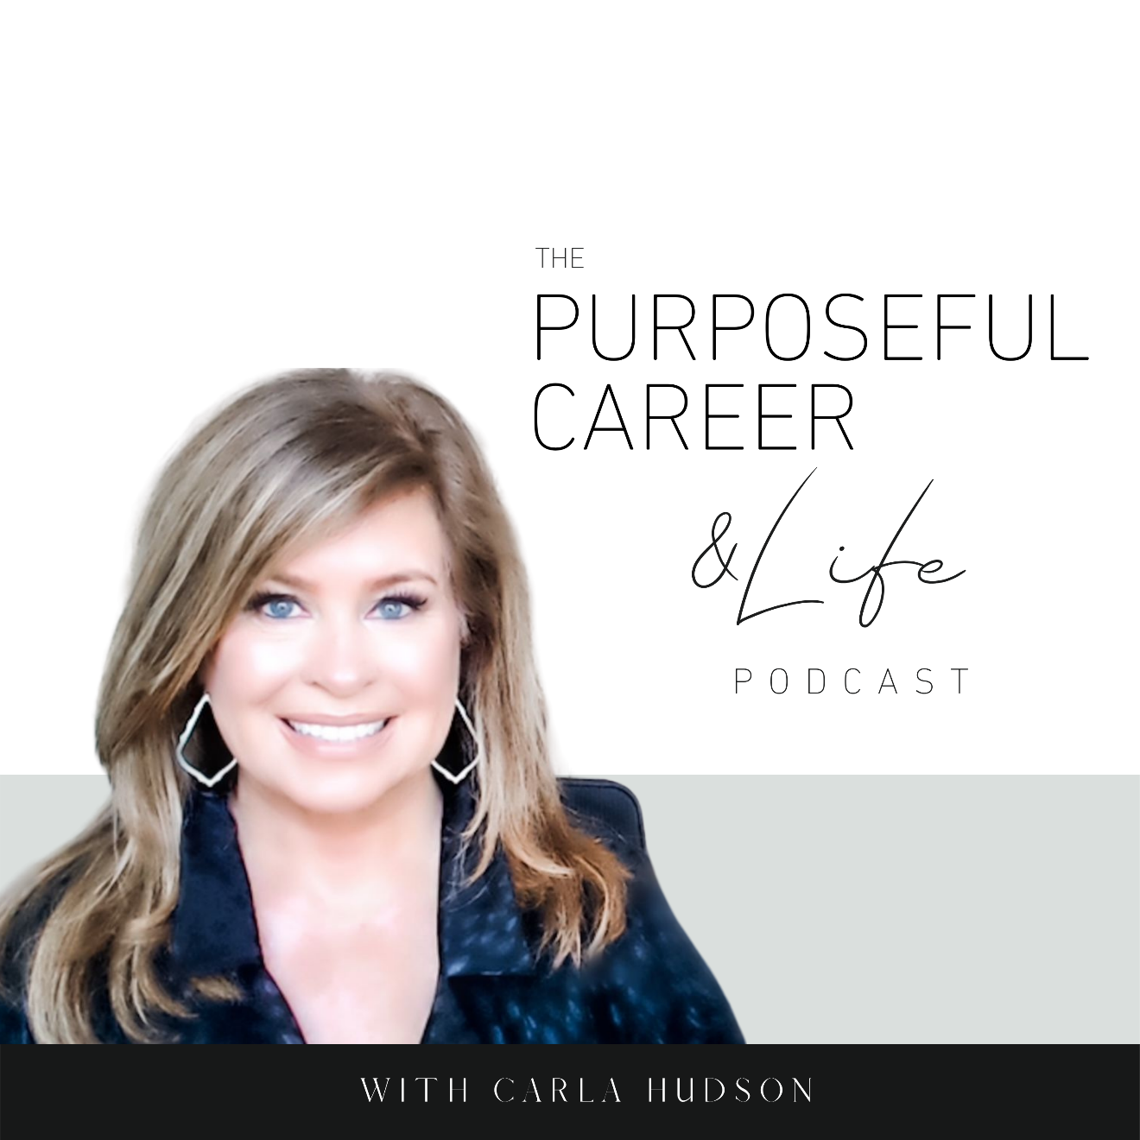

Being in Uncertainty

July 25, 2021
Well, hello Friends.
I hope you guys had an amazing week.
I can’t believe we’re at the end of July AND I can’t believe this is the 30th episode of the podcast. Wow.
You know…when I started the podcast at the beginning of the year, I was so clear about what I wanted it to be. I KNEW it was going to be an important part of my coaching practice. A way to reach people who might be in transition or reaching for something new or maybe struggling in some way in their career or life. But I had no idea what it would do for me. It’s been absolutely amazing, and it’s become one of my favorite parts of the week. And that’s because of how it feels to bring you guys a new episode every week. I always try to focus the episode on solving a specific issue you might be having. And in doing so, I think that brings me closer to each of you.
I’m SO grateful for those of you who are regular listeners and if you’re new here this week, welcome! And I want to invite you…if there’s an episode you find particularly helpful, please share it with a friend or on your social handles. And we’d be so grateful if you’d give the podcast a rating or review on Apple or your favorite platform. That helps us reach and help more people.
But most of all, I want to say I am SO GLAD you’re here today.
SO! Let’s get into today’s episode.
Today I want to talk about Being in Uncertainty.
I was originally going to talk about something different but with the news of the virus being on the upswing in almost every state (and around the world) and with that, delays in returning to the office and putting a return to the classrooms in question, I know this is something that would be helpful for everyone.
It’s been quite the year of uncertainty for everyone with Covid. We weren’t sure if our family or friends would stay healthy. We dealt with shortages of goods, services, HOMES! Parents learned to do double duty as teachers. Kids gave up sporting events. And we all sequestered in our homes feeling isolated and UNCERTAIN.
And in the work context, many of us were thrown into virtual work. In person meetings turned into Zoom. Some people lost their jobs altogether leaving them in uncertainty as to when hiring would even restart.
It’s been a year of over-the-top uncertainty. But the truth is, our lives and our careers are ALWAYS uncertain. No matter how hard we plan or how faithfully we follow that plan or how hard we work or whatever, we are not always in control of what happens to us.
And while we all know that the future is uncertain. That we can’t know what it waiting for us up ahead, we’re always surprised and unsettled when the unexpected happens. And that’s when uncertainty flares up, right? When we are suddenly forced to deal with the unexpected. And I would say that most of the time it’s not only when the unexpected happens but more specifically, the unwelcome thing happens.
Covid.
The layoff.
The reorg.
The new boss.
And when it happens, we feel uncertain.
But what IS uncertainty exactly?
I looked up the websters definition and it wasn’t helpful. It described it as a “state of being uncertain.”
Wikipedia’s was right on point though. It described it as a ‘Measurement of risk. A state of limited knowledge where it is impossible to exactly describe the existing state or a future outcome; where some possible outcomes have an undesired effect or could represent a significant loss.’
Interesting right?
So, when we’re uncertain, it’s really because we’re looking at the thing that just happened and not able to know, with certainty, what our future will bring.
That’s because right behind the uncertain is a feeling of being out of control. We no longer feel that the things we used to be able to count on – our routines, our plans, our daily habits. Now we’re living in a different reality. One we didn’t create. One where we’re not in charge of everything that might unfold. And one that might not turn out the way we want.
Uncertain creates a feeling of being out of control which makes us uncomfortable and at worst, fearful.
When we experience uncertainty, most of us try to reduce this feeling of discomfort by trying to take control.
For example, one of my clients, when faced with nonstop rumors of a major reorganization that was thought to be imminent, dealt with it by spinning up an aggressive job search. Unable to deal with the anxiety of waiting to see what might happen and whether it could actually work in her favor, she soothed herself by applying for job after job after job, telling herself that if change was coming, she’d rather be the one to choose it instead of having it foisted off on her.
This is of course not the reason to do something as important as changing jobs. The truth is underneath her feverish applications was a deep need for feeling certain and in control of her destiny. We ended up addressing the core issue, which was allowing herself to get uncomfortable with uncertainty.
By the way, this is a core skill we should all cultivate – not only in our career but in our life too.
Why should we learn to be uncomfortable with uncertainty?
Because you can’t EVER escape the uncertain. Our entire future unfolds before us in unpredictable ways. No matter how hard we plan or how much we try to direct where it goes, things happen that we can’t foresee.
For example, if my client HAD selected a new job and made that move, she might have felt more certain or in control in that moment. But I can guarantee you that in the new job she might have run to, things would’ve happened in that environment that she felt equally uncomfortable with.
We can’t control our way our of uncertainty.
BUT, there are two helpful things we CAN do during times of uncertainty.
First, we can shift our focus to what we CAN control.
So, if you lose your job unexpectedly, establishing a structured routine is one of the FIRST things that can help you feel more in control. So is learning a new skill, taking a certification course, connecting with friends and family.
Or in the case of my client who was plotting her escape to greener pastures, she shifted her focus to herself. So, she moved FROM thinking nonstop about the catastrophic ramifications (in her own mind) of that upcoming reorganization and instead started an intense evaluation of where she was in her career and where she might want it to go. She signed up for a new certification and doubled down on showing up as her best every day. She finally accepted that SHE wasn’t in charge of the reorg, but she WAS in charge of pursuing a new interest area and ensuring that the work she delivered every day was her absolute best.
Or maybe for you it’s an unexpected medical diagnosis. Or maybe your child is struggling at school. Or maybe a long-term relationship just ended.
The first thing you can do to feel BETTER is to shift your focus FROM the scary unknown future or the thing happening that you are not in charge of TO yourself. Because YOU CAN control how you show up every day. YOU CAN decide to ask yourself a very simple but potentially life changing question when the unexpected happens and that is questions that help you answer ‘now what?’
“What new things might be possible for me now that my life is different?”
“What kind of life (job, relationship, partner, whatever) would I like to have when all of this is done?”
So, first was focus on what YOU can control.
And the second thing is to Imagine the Most Likely Scenario.
You see, when we feel out of control, we generally imagine the worst possible thing happening. Psychologists call this catastrophizing.
And when we focus on all the bad things, we feel BAD, SCARED, FEARFUL.
But the truth is, the worst possible thing RARELY happens. Sometimes it does, but it’s never helpful to focus on that possibility.
Like in the case of my client dreading the reorg, underneath all of that was a panic about maybe losing her job. This fear came from the fact that her father had lost his job when she was young, and the family struggled for a few years while he looked for work. So, even though she was a high performer and doing fine at work, she imagined that the reorg would result in her being out of a job. And her initial way of dealing with that was panic applying for other jobs.
If this is where your brain tends to go, it can be helpful to remind yourself that the worst-case scenario is only one of many possible outcomes.
For this, I like to have my clients to an exercise that has them document the worst that could happen.
Then document the complete opposite – the BEST that could happen.
And then, identify the middle scenario – somewhere between the worst and the best – which is the most likely thing that could happen.
When you allow yourself to realize that just because you’re feeling uncertain and out of control, it doesn’t mean disaster is right around the corner, it can help you more readily accept that you’re in a period of uncertainty.
And to allow yourself to just kind of go with it.
So next time something unexpected or unwelcome has happened or is rumored to happen and you’re feeling uncertain, shift your focus back to you and remind yourself that this is the perfect time to ask yourself a new and very important question.
What might be possible for me now?
And then, get on with it.
Until next time, make it a great week my friends.

