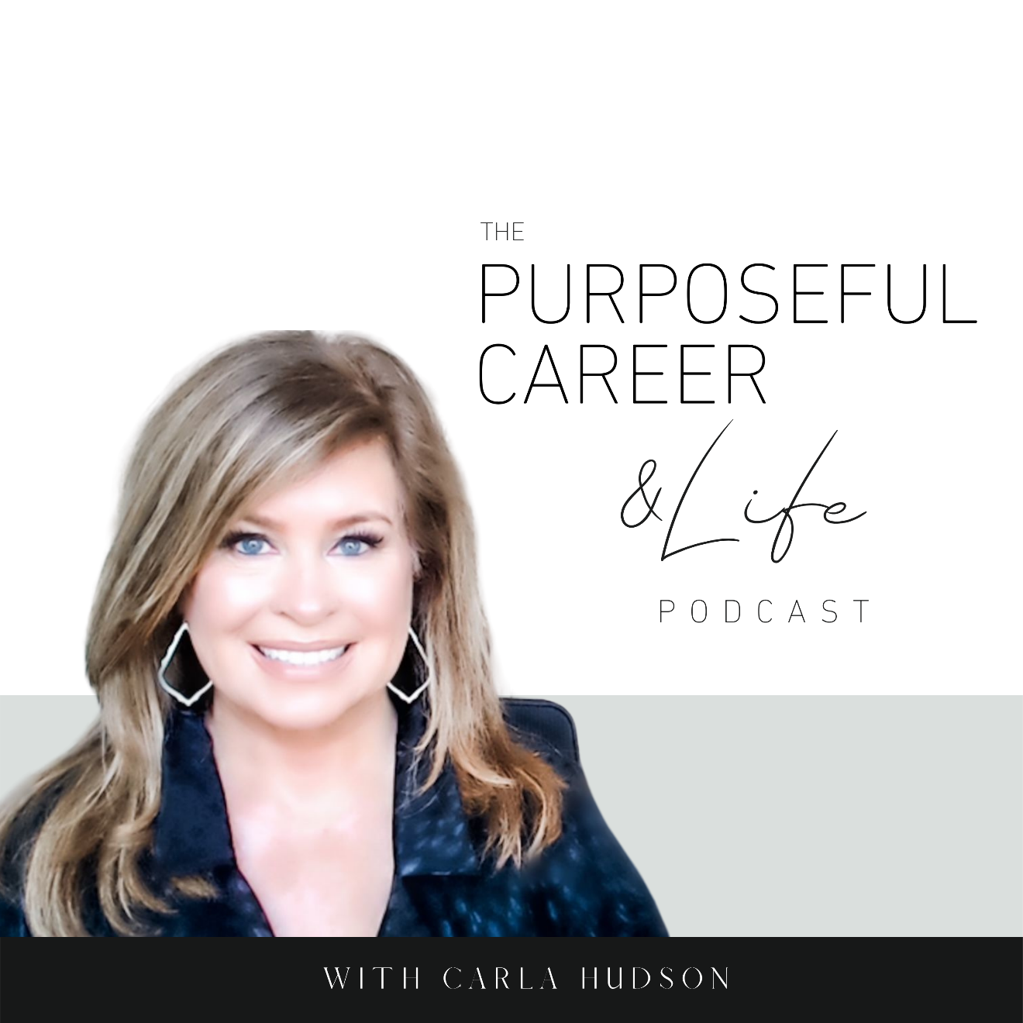

Ask the Coach

“I don’t know what to do

with my career.”

July 28, 2021
Well, hello Friends!
Welcome to this bonus episode of the podcast, which I’m calling Getting Real Wednesday. Like I said, we’re experimenting with this new segment, which I’ll plan to do the last Wednesday of the next few months. If you like it, we’ll keep doing it.
You guys submit your questions to me and I’ll answer them. They can be about anything related to your career from job searching and purpose to getting promoted, getting laid off or changing career paths. Even starting a side hustle or business. Whatever you want to know more about or get a different perspective on, fire away. I’m here for ya.
SO, TODAY’s question is definitely the one I get asked most frequently so, I wasn’t surprised when several came in that were sort of similar. They all centered around the theme “I don’t know what to do with my career.”
Now there were several versions of this questions.
“I don’t know what I’m good at.”
“I don’t know what I SHOULD be doing.”
“I don’t know my purpose.”
They’re all dancing around the same question of how to know what to do with the time you spend working.
So, let’s dive into the answer. Because there are three parts of this that I want to address.
The first part is the “I don’t know” part of the question.
Because this is something most of us do at one point or another and most of us aren’t connected to the issues it causes.
Now I know when we’re trying to figure out something important and we think “I don’t know”, it certainly feels true. I’ve been there many times myself, believe me. Not just as it relates to career but also to relationships and other things.
But the issue is “I don’t knowing” yourself is a very good way to get stuck. That’s because when you tell yourself “I don’t know” you’re turning off or ignoring the part of you that DOES know. The intuition part.
After all, YOU are the one who knows YOU best. So, the answer to what you’re great at or what you want to do with your work life HAS to come from you. That’s the only way to be sure that you’re doing something that’s aligned with your unique gifts, wants, desires. I mean, none of us want to spend 30-40 years doing what someone ELSE wants us to do with our life, right? What we do with our life gets to be about us. Never forget that.
The other thing about this is, I believe we all KNOW what we’re good at and what we’re interested in. Sometimes we just don’t allow ourselves to KNOW it.
Now that doesn’t mean you’re doing it on purpose. You’re not. ”I don’t knowing” yourself is usually an automatic thought our brain will serve up as a way to protect you from the implications of what would happen or what scary things you’d need to do, learn, master or try if you DID KNOW.
Think about it for a minute. If you “don’t know” you don’t have to do anything hard or scary or where you might fail.
But if you DID know, you’d have to put yourself out there and try or live with the fact that you were too scared to do it.
I don’t know is a protection mechanism. Self preservation.
Here’s what I mean.
Deep down, many of us have a lot of fear when it comes to our career.
We’re not sure we’ll be successful.
We’re not sure we can get hired in the area we want to work.
We’re not sure we’re good enough at the thing we want to do.
We’re afraid of trying and failing.
We’re afraid of what others will think.
We’re afraid of how our life or relationships might change if we DID do the thing and WERE successful at it.
So, we tell ourselves we don’t know to protect ourselves from having to face it.
And if we stay in that place for a while, we DO get disconnected from knowing what we’re good at or what we want or whatever. Because we shut off that inner voice that actually DOES have the answer you’re looking for.
If this is you, here’s a helpful exercise.
Take out a pen and paper or open a google doc. At the top, write “What I want to do with my career.” And a few other questions it’s helpful to ask are “What I’m great at.” And “What I’m interested in.”
Then start writing.
Write whatever comes up for you.
And keep writing until you’re done.
Do not edit, judge, or tell yourself it’s impossible.
No telling yourself that you’re too old or too young or whatever.
Just capture all of it.
And if your brain still tells you “I don’t know,” ask yourself a different question: “What would I write down if I DID know.”
And start writing.
Most people are amazed at what happens when they turn off “I don’t know” and turn on “What if I DID know.”
The more you do this, the weaker your “I don’t know” mechanism will become.
You’ll gradually get in touch with that inner wisdom that’s inside all of us. And you’ll learn to listen to and trust that gut instinct.
Never forget. YOU know what is best for you. And it doesn’t matter what anyone else thinks.
So the first part of my answer is stop “I don’t knowing” yourself and get in touch with your areas of interest, what you’re interested in and etc.
The second part of it.
Sometimes we get stuck because we’re making the decision BIGGER than it needs to be.
Here’s what I mean.
You are not making a single decision that HAS to carry you for the next 30-40 years.
You’re making a decision that’s your RIGHT NEXT STEP.
Of course, some people will pick a profession and will love it just as much for the next 30-40 years.
But I think that’s too much pressure and it’s just not true or best for most of us
And honestly, I think when we have that expectation, it can close us off to other possibilities that might reveal themselves to us down the line.
So, think about your decision as picking THE RIGHT NEXT STEP.
So not a 40-year time horizon. More like a 1–2-year time horizon.
That means, pick something that is of interest RIGHT NOW and then PURSUE it.
This will begin your journey.
As you dive into that Right Next Step, you’ll learn new things, meet new people, get exposed to new ideas and possibilities and as a result, you’ll become the next level version of yourself.
Then you can make the NEXT right next step.
And that cycle ideally repeats itself over and over in your career.
Of course, if what you pick at the beginning is what you end up loving forever, that’s amazing!
But don’t put all the pressure on yourself to have to know that NOW. Most of us don’t.
Allow yourself to continue a never-ending journey of discovery, learning and continual evolution that is guided by your ever-evolving interests, and skills.
And the last thing I want to share is that it’s important to go beyond “professions” into what I call the under lying skills you have or things you like to do.
Because in my view, that’s where our true job satisfaction comes from. And, when you get in touch with the skills level of your interest vs. the profession (like marketing, sales, or whatever), I think you’ll be more satisfied.
Here’s what I mean.
Maybe you like working with people.
Maybe you LOVE solving problems.
Maybe you have a knack for numbers.
Maybe you like interpreting data into strategies.
Maybe you’re an idea person who likes all things innovation.
Maybe you like writing or design or gardening.
Maybe you love structure and routine (or maybe you hate it).
Maybe you like all the details of planning an event or managing a complex project.
List all the skills.
Because when you know THIS, it’ll add a dimension to your search.
And, you will find that many of your skills are transferrable and apply to several fields.
Like a career is marketing is great for people who like solving problems, working with numbers, coming up with new ideas, managing complex initiatives.
Whereas, a sales career is great for people who LOVE working with people, solving problems and maybe being out and about vs. stuck in an office.
A good framework to use is.
What I like or am interested in.
+
What I’m good at.
+
What I can earn money doing (i.e. the job or profession)
By answering the first two, it’ll help you research and home in potential career fields that might suit you.
Until next time, make it a great week my friends.

