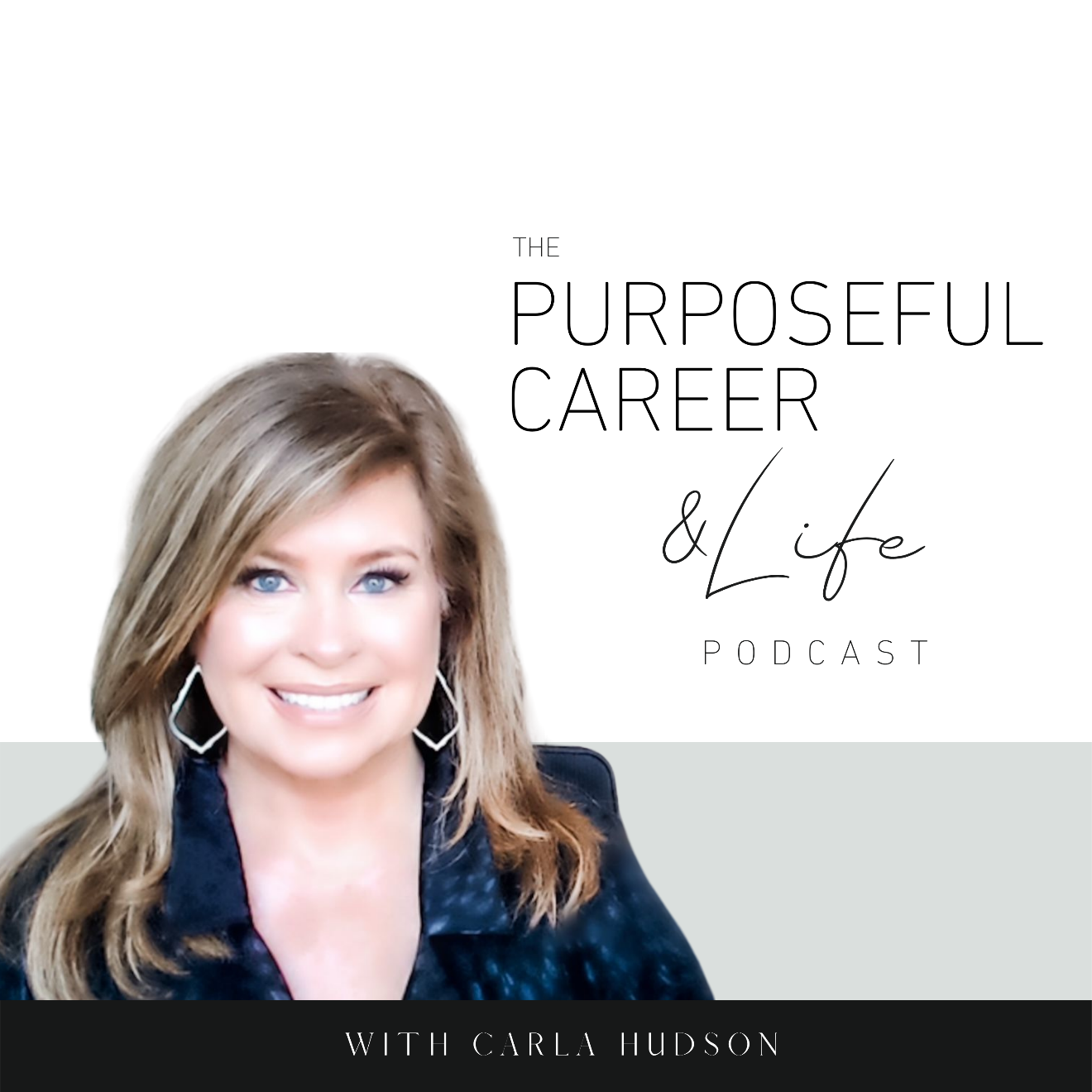

Creating Self Confidence

August 1, 2021
Well, hello Friends! I hope you guys had an amazing week.
Today I want to talk to you about something that’s foundational to having the career or business you want. And that is self-confidence. Because you aren’t going to get very far if you don’t believe you can.
Most of us believe that people are either CONFIDENT or they’re NOT.
That SELF-CONFIDENCE is an attribute we’re born with.
But it’s not.
Self-confidence is a skill we develop if we choose.
And it’s definitely a skill WORTH developing because being self-confident is linked to having greater success, making more money and overall having a happier and more satisfying life and career.
I’ve got a lot to share on this topic and it’s something that affects so many people, so let’s dive in.
The first thing I want to share is that there’s a difference between CONFIDENCE and SELF CONFIDENCE. And it’s very possible to have ONE without the OTHER.
But before I share the difference, I want to first share what both words have in common and that is, that confidence comes from the Latin word meaning TRUST. So, confidence is about having TRUST in yourself and your abilities.
But where they differ is that CONFIDENCE is backward-looking, and SELF-CONFIDENCE is forward-looking.
You gain confidence through experience.
You learn to trust or have confidence in your ability to DO SOMETHING when you’ve already successfully done or achieved it before.
Self-Confidence on the other hand, IS FORWARD-LOOKING. It’s about having belief or trust in yourself and your ability to do things even though you’ve never done them before.
So, confidence is based on having tangible proof. That’s where KNOWING you can do it comes from. Whereas, self-confidence is about a having faith or TRUST in your ABILITY to do something; to figure it out.
So, if your boss asks you to lead an initiative and you’ve successfully done dozens just like it before, you are very confident in your ability to be successful at that thing.
You’re probably not going to worry whether you can do it, wonder whether others will judge or criticize you or get stuck in indecision or overwhelm. No, you’ve done it. So, you know you’re going to rock it.
But if your boss asks you to go do something new that you HAVEN’T done before and you’re NOT a self-confident person, you might feel the instant flare-up of self-doubt. And you’ll wonder things like “what if I can’t do it?” “what if I look foolish?” And even when you dive in, you’ll likely continue to torture yourself a bit with those doubt.
Whereas if you ARE self-confident and your boss asks you to go do something new you haven’t done before, you immediately start thinking about how to go do it. You’ll plan it out, chunk down the actions, pull other people in who’s skills or experience you need, put it on a timeline and then go do it.
Look at the difference between the NOT self-confident you and the Self-confident you in these examples. The NOT self-confident you is full of anxiety and tortured thoughts that make your life so miserable even if you DO manage to get the thing done you’ll feel miserable doing it. Whereas with SELF confident you, there’s no drama, because you’re too busy figuring out how to do it to even wonder about all the what if’s that could go wrong.
I’m thinking we’d all rather be the self-confident one.
The non-self confident one is probably going to learn to be overly reliant on feeling confident whereas the SELF confident one is going to become great at managing feelings of discomfort.
And this is important because if we want to grow, we’re going to have to learn to get comfortable trying and maybe failing at NEW things. When we rely too much on ‘feeling confident’ (and all the positive emotions that brings), we can actually get stuck in our careers.
We can become afraid to move forward because to do so would mean moving away from things we KNOW (for sure) how to do and move into NEW things we’ve never done before.
In order to have a purposeful career – one that is aligned with where you want to go – means you must learn to cultivate SELF CONFIDENCE. So, you build your inner trust and faith in your ability to get out there and try. To take action even when it’s scary.
Because think about it. If you lack a strong trust or belief in your ability to learn and achieve new things, you’re not going to put yourself out there.
You’re going to turn down new opportunities.
You’re going to listen to your inner critic who’s telling you it’s a bad idea to try. That putting yourself out there will make you look foolish. Or might get you fired. Or whatever.
I’m convinced not being self-confident is part of the reason so many people get stagnant in their careers.
Now that’s not to say that if you love what you do and you’re fulfilled by it that it’s a bad thing to stay in the same job for ten, twenty years. It’s not. Only you can know whether or not that same job is truly fulfilling. There’s a lot to be said for loving what you do so much that you just want to go deep in that thing and become an expert at it.
But for most people, staying where they’re at – not allowing themselves to shake things up, take chances, try new things, start the side hustle or business, ask for the promotion, accept the speaking gig – for most of us, it’s about fear.
We don’t trust or believe we can do it. Maybe because we’ve listened to overly-critical things others have said to us.
Or maybe because we have an overactive inner critic that spews constant negativity into our heads.
If this is an issue for you, listen to the Inner Critic series on this podcast – episodes 6-9. It’s got some great insight and some helpful tips on how to soothe your inner critic.
Self-confidence is really A LEARNED PATTERN OF THINKING ABOUT YOURSELF.
And since it comes from the Latin word for trust, the idea of being able to count on yourself and your ability to do what you say you will do is at the heart of it.
So we build this muscle by getting CLEAR on what we want to go do. And then, taking the consistent action to do it. Even when we don’t know how. And not quitting on ourselves.
It’s about being able to COUNT on yourself.
Because our confidence in ourselves gets shaky when we SAY we’re going to do something and then we DON’T FOLLOW THROUGH and actually do it.
We don’t get started. Or we quit halfway through.
So it’s about trusting yourself. But underneath that, it’s about COMMITING to the things you say you will do. No. Matter. What.
For this, I like a quote I got from Jen Sincero, author of the You’re a Badass books, which is “So often, we pretend we’ve made a decision, when what we’ve really done is signed up to try until it gets too uncomfortable.”
Truth.
Think about your own life for a minute. How has this shown up for you?
How many diets have you started and stopped?
How many hobbies have you started and stopped?
How many times have you PROMISED YOURSELF you’d speak up at that meeting and then didn’t?
How many times have you promised yourself you’d ask for the promotion, but didn’t?
How many times have you turned down the very things you crave: speaking engagements, big new scary opportunities? And then wondered, “what is WRONG with me?”
Every single time we make a promise to ourselves and then we don’t follow through, we erode our self-confidence.
Until next time, make it a great week my friends.

