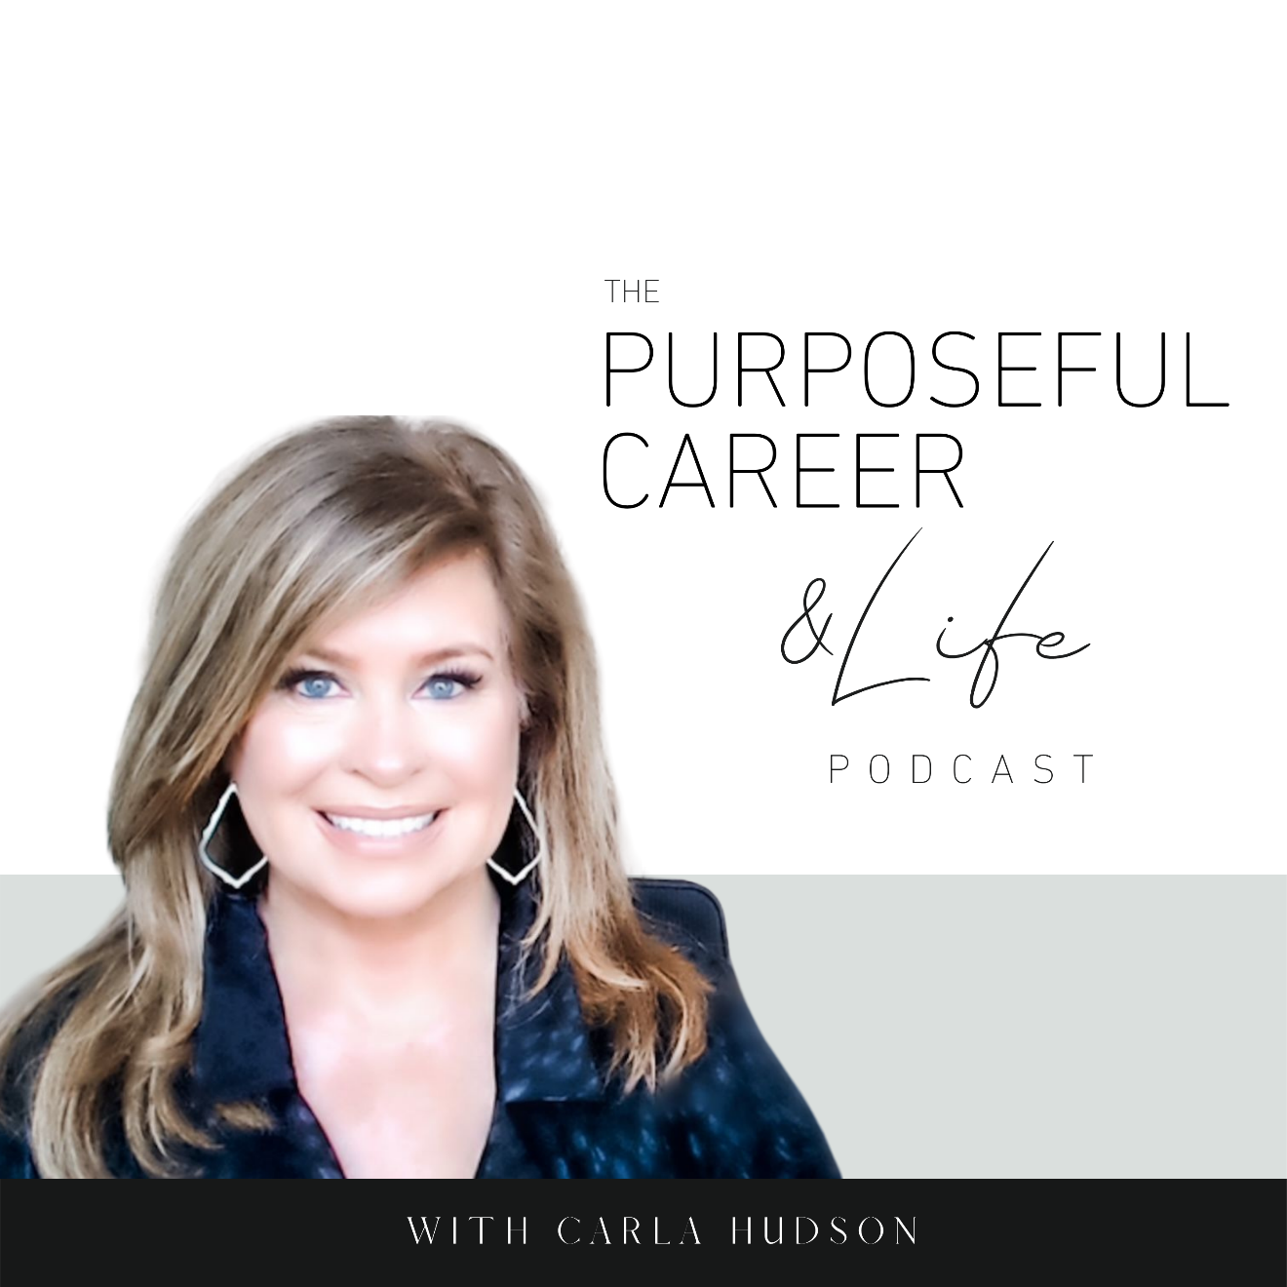

How Others Label Us (#2 0f 2)

August 14 2021
Well, hello Friends! I hope you guys had an amazing week.
Today is the second in our two-part series on Labeling.
Last week, we looked at “why we label others, how it impacts us (and others)…and how to stop doing it.”
In that, we explored the origins of labeling as it relates to our human brain.
We learned that our instinct to label comes from the primitive part of our brain and that in ancient times, this ability to “INSTANTLY categorize” people and situations actually served a purpose. It helped our caveman ancestors recognize danger so they could make decisions to keep themselves safe.
This tendency to ‘instantly label’ for modern man is counterproductive except for maybe those situations things like our brain labeling it a “super bad idea” to walk down the dark alley alone.
But other than those types of situational things, labeling doesn’t serve us in the modern world we live in. And in fact, when we label others, it keeps us apart from others because we’re standing in judgment instead of looking for opportunities to connect or learn more about someone.
And for the person BEING labeled, it’s even worse. Labels hold people back and isolate them from opportunity and relationships.
Bottom line, we don’t want to be the person who assigns instant and unfair labels to others.
And yet, the impulse to do that comes from the part of our brain that is ALL ABOUT instinct. The fight or flight part. The part of your brain that just instantly REACTS, without you even realizing it, because it wants to avoid danger or things that are unfamiliar.
So, if it’s instinctive, how do we stop it?
We stop it by becoming aware of the fact that you’re doing it.
And by deciding to consciously NOT do that by taking steps to counteract that instinctive part of your brain. We talked about how to do that in our last episode. So, if you haven’t listened to episode 33 yet, please go back and do that because I think you’ll find the self-exploratory questions and tips on how to fight that urge to label super helpful.
Now in TODAY’S episode, we’re going to look at what happens when WE get labeled. And there’s two ways that happen.
First, we label ourselves.
And second, we get labeled by others (just like WE label THEM).
As you know, my business is all about helping people understand that having the career and life you want comes FROM YOU. We create our success FROM THE INSIDE OUT. This is not how we think it works. We think our success comes from finding that elusive combination of ideal circumstances.
I know that’s what I thought for a long time.
But it’s not true. If we want to achieve our goals or have the success working for others or for ourselves, it requires us to be STRONG from the inside out.
The reason this is important is that it takes real awareness and practiced effort to overcome our brain’s primal instinct to be overly critical of ourselves. Or, to stay strong when we’re around people or in an environment that for whatever reason, doesn’t welcome who we are.
Because when we’re talking career we have to acknowledge that it involves people and people aren’t perfect.
We’re going to encounter bullies.
People who say rude things.
People who stab us in the back.
Teachers or bosses who tell us we “can’t” do something or who are unfairly critical.
Internal politics and organizational power structures that – whether intentional are not – are meant to ‘label’ others as a way of determining whether you’ll be listened to or not.
So, during those challenge – which we all encounter – it takes REAL DISCIPLINE to stay strong and self-empowered despite the challenges that we know are always going to be there when it comes to our careers.
So, let’s look deeper at our tendency to SELF-LABEL, because I honestly think this one is most challenging.
The problem self-labeling is that MOST of the time, the labels we give ourselves ARE NEGATIVE.
They come from our Inner Critic, that negative internal talk track that for most of us, is always running inside our head.
The tendency to self-label STARTS in childhood and for many of us, continues and even grows, throughout our lives.
It happens through the combination of the things people say to us – the offhand remark, a calculated insult, “teasing”.
Or through the experiences we have…not making the team, not performing well at a sport or in a field of study, difficulty forming friendships. We make all those things MEAN SOMETHING (usually negative) and that turns into self-judgments, which is another word for self-labelling.
Here are some of the most common.
Loser
Lazy
Stupid
Crazy
Bad
Fat
Ugly
Nasty
Terrible
Weak
Worthless
Recognize any of those running on a loop in your head?
Or do you have some other go-to’s?
Maybe not all the time but in certain situations?
When you step back and really take a hard look at the labels many of us assign to ourselves, iIt’s easy to see that when you think of yourself as a “loser” or “bad” or “demanding” how that might cause you to feel “not good enough” or “unworthy” or like “there’s something wrong with you.”
And when you feel that way, what are you going to do? You’re going to shrink down, play small, hold yourself back.
If some of those self-labels sounded familiar to you, could this be the reason you stay in that dead end job?
Or don’t pursue REALLY trying to lose weight.
Or don’t pursue that career change.
Or don’t enroll in grad school.
Or don’t go for the promotion.
Or don’t accept the speaking engagement.
When we assign a negative label to ourselves and then repeat that label over and over and over again in our mind, it becomes deeply ingrained. It becomes a THOUGHT PATHWAY, which we discussed in Episode 25, so we know that it’s the repeating of thoughts over time, that form our beliefs.
And in the case of self-labeling, they form LIMITING SELF-BELIEFS.
But like I said earlier, labeling ourselves isn’t the only way we get labeled. Sometimes we get labeled by OTHERS.
Parents.
Siblings.
Teachers.
Bosses.
Friends.
Acquaintances.
Co-workers.
You see, these people have the same instinctive need to ‘instantly categorize’ others and if they’re in your world, they probably also label YOU.
And sometimes those labels are intended to be positive, like…
She’s the smart one in the family.
Or the beautiful one.
Or the tom boy one.
And sometimes those labels aren’t so positive, like…
She’s the pushy one.
Or the overweight one.
Or the quitter.
Or the demanding one.
For example, even though society is expanding their views of women, there are still many workplaces where if a woman is assertive or outspoken or champions her own ideas too passionately, she risks being labeled aggressive, demanding, overpowering.
This causes so many of us to play small, stay silent, shrink down to fit into this ‘smaller view’ of who others think we should be in order to be “acceptable” to them.
And that’s just one example based on gender. There are so many other ways that the opinions or judgments of others cause us to think about ourselves in a negative way.
And even if the label is INTENDED to be positive, like you might be thinking there are worse things than being labeled “the smart” or “the pretty” one, the truth is these labels STILL DIMINISH US because they narrow in on one part of who we are instead of acknowledging all that we are.
This causes some people – who make the mistake of BELIEVING these “positive” labels others assign to them and who then over index or over value that ONE part of them instead of trying to develop in other areas. And this is never a great idea.
So, what do we do to handle being labeled – whether by ourselves or others?
We DECIDE to focus on and value ALL that we are. We get to decide who we believe that we are and what we are capable.
You don’t have to believe things others have said about you. You can’t stop others from assigning a label to you. But you can decide whether to let it impact you.
And when it comes to self-labeling, you don’t have to keep believing that just because you failed at something or have some less perfect qualities, that it means that you’re doomed or a loser or whatever it is you think you are.
The truth is that the way you think about yourself is a habit.
Did you know that?
Those negative labels running in your brain and the nasty things your inner critic sometimes says to you AREN’T TRUE. They’re just thoughts you thought once and then kept thinking over and over and over again.
You don’t have to keep dissing yourself. You change shift that recurring pattern of thought by just DECIDING what you’d rather be and then practicing that discipline over time. You’ll then weaken that undesirable “neural pathway” and you’ll begin building and strengthening a new one that DOES serve you.
By the way, deciding you want to believe good things about yourself, doesn’t make you vain or a narcissist or whatever. It just means you’re choosing to focus on the good things, the things you appreciate about yourself.
And did you know that the exact same thing works when you have OTHERS that are labeling you?
Maybe even BULLYING or berating you?
When others are putting unfair labels on you, your point of power is in DECIDING not to listen.
NOT to believe it.
Instead, decide what YOU choose to believe about YOURSELF. And place more emphasis and value on THAT.
You’ll be amazed what happens, what positive changes come about in relationships, working environments when you make that shift. That doesn’t mean that bullies will magically change their ways. They usually won’t. And you certainly can’t do anything to change them. They’re be a bully or practice bullying behavior as long as they choose to do that.
But when you value what YOU think about you more than what others think, you’ll make clear-headed decisions on whether you should stay at that job or in the relationship or wherever that negative labeling is coming from.
Trust me when I say that this is life-changing.
Imagine believing from a young age that your sibling is the “smart one” and “you’re the average one.” The series of decisions you’ll make, the coasting, the not going after the dreams because what is the point. When you decide to drop that label, your life and your possibilities open up.
As always, so much of the real wisdom in this world comes from simple things we’re taught in our childhood. Like when someone is mean to us in grade school and our parents told us “Sticks and stones may break my bones, but names will never hurt me.”
Might sound trite and over-used and maybe even a little old fashioned into today’s profanity-laced society (which I refrain from on this podcast but believe me, I am guilty of too). But the truth is that the wisdom in that phrase is life changing.
Whether the name-calling is coming from your Inner Critic or the work colleague, YOU’RE really the one calling the shots. Because you get to decide NOT to believe it.
Until next time, make it a great week my friends.

