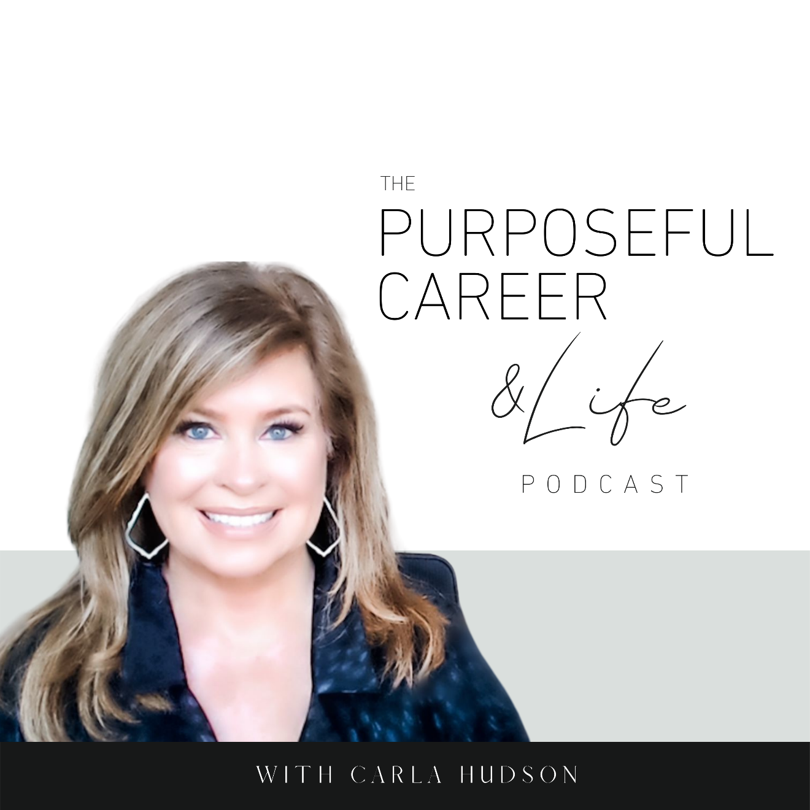

Making Decisions in

Uncertain Times

August 21 2021
Well hello Friends! I hope you guys had an amazing week.
Today I want to talk about how Decisions in Uncertain Times.
As we all know, life is a constant lesson in uncertainty. And we kind of get used to it, right?
We’re all aware that we never know what’s around the corner. What tomorrow will bring. Or even if we WILL be here tomorrow.
But as we grow up or grow into situations, we get used to what I call “the uncertainty we know.” We’re all pretty resilient when you think about it. We get used to kind of not being in control of what might happen to us.
I mean, if we didn’t, we literally wouldn’t be able to leave the house.
Because what might happen if we step off the sidewalk? That speeding car might run the red light.
Or merge our car onto the highway at 70 miles per hour.
Or take the new job that we’re a little scared we might not be able to excel at.
Or move to the new city where we don’t know anyone.
We don’t REALLY know how the NEW things we try are going to work out.
We HOPE for a specific outcome, but inside, we KNOW it might not turn out the way we want.
And yet, we get used to facing these ‘familiar’ unknowns. I call them the KNOWN unknowns.
And this helps us to get on with the business of our life.
It helps us make decisions about our future, both big and small, while not being sure if it’s all going to turn out okay.
We get comfortable playing the hand we’re dealt. And even when we didn’t know what card we might be dealt next, we’ve learned to place bets and make decisions so we could keep moving forward.
But what happens when we face NEW Unknowns?
Like Covid.
That just might be the biggest UNKNOWN of the last several decades.
I mean, it’s been surreal.
Think back just two years ago, to September of 2019.
Who could’ve predicted that just six months later, the entire WORLD would shut down in like…two weeks?
Restaurants closed.
Grocery shelves emptied.
Sports seasons cancelled.
Kids in virtual school.
No proms, graduation ceremonies or any of the other rites of passage we could always count on.
We were all living in a dystopian Hollywood pandemic movie. Except it was real.
The entire world entered a period of an EXTREME NEW UNKNOWN.
And it kind of sucked.
Covid snatched all our BAU playing cards and flung them up in the air. We could no longer count on ANYTHING we’d previously taken for granted.
But what’s interesting is the different ways people handled it.
A huge segment of the population kind of hit the PAUSE button on their life. They stopped making decisions about the future – no vacation planning, no weekend activity planning, new job searches, no nothing. Instead, and I’ll include myself in this for a good part of that time, we kind of hunkered down and WAITED.
Waited for a vaccine.
Waited for mask mandates to be lifted.
Waited for companies to start hiring again.
Waited for it to be safe to travel to see friends and family.
Basically, this part of the population DECIDED to WAIT instead of using the time as a way to reflect on new possibilities.
And that’s what’s at the heart of it right? We DECIDED to WAIT.
But not everyone handled it that way.
There’s a good percentage of people who DECIDED to Make Plans. Even amid the closed businesses, the loss of jobs, the illness, the children studying at home. They kept making decisions about their future.
They saw the shutting down of the world as an opportunity. The classic, when one door closes another open’s philosophy.
And so, we saw people use the remote work as the perfect opportunity to move out of the city they didn’t really want to live in.
Apartment dwellers bought homes so they could have more space.
Corporate workers started businesses.
Laid off workers went back to school.
So, think about it.
Both groups were faced with the same catalyst – the virus – but while some decided to WAIT it out others used it as a huge catalyst for change.
So, what’s the difference between the two groups?
Both groups were making decisions about their future.
The difference is in what they chose TO FOCUS ON.
Those who hunkered down and decided to WAIT were focused on the scary NEW VIRUS and the danger it represented. And granted, it IS scary…I’m not saying it’s not. It has killed millions of people around the world. So, I was right there in the WAITING camp for a long time.
In fact, in a very important way, I’m STILL waiting.
Waiting while I figure out if it’s safe to go see my parents, who I haven’t seen since Christmas of 2019. They’re older. They’re vaccinated. But should I get on the plane? Is it safe to rent a car when I get to the airport? What if they get a breakthrough infection?
Can I live with the things that might happen?
And on the other hand, can I live with NOT going and letting more time pass by without seeing them.
And what’s underneath that?
Fear.
A feeling of risks I’m not willing to take on.
Not feeling safe.
Feeling like the world is out of control.
So, up until now, I’ve continued to WAIT. I’ve DECIDED NOT to decide to go visit.
So you see, I get it. When I talk about DECIDED to wait for things to return to normal, this isn’t coming from judgement.
And it doesn’t even take something as extreme as a pandemic to keep us in deciding to not decide.
Any NEW UNKNOWNS we face – like being laid off or deciding to leave a relationship or whatever – can cause us to get stuck right where we are.
But what I want you to see is that we’re ALWAYS deciding.
We’re either deciding to stay right where we are (which is code for being stuck). Or we’re deciding to move towards something new.
We’re always deciding. We’re never NOT deciding. Even when you think you’re being Indecisive, you’re not. You’ve DECIDED not to decide.
So, if we’re always deciding, how do we make decisions that serve us?
By being intentional about what YOU CHOOSE to focus on. Because that IS a choice.
When you’re offered that new job, will you focus on what could go wrong? Or will you focus on what could go right?
If you DECIDE to focus on what could go wrong, you’ll feel fearful, scared and out of control.
If you DECIDE to focus on what could go right, you’ll feel hopeful, excited, and inspired.
Some people tell themselves they’re just a realist.
That by preparing for the worst, they’ll be ready for the bad thing.
But really, all this does is KEEP us grounded in fear and feeling out of control
We’re thinking about the bad thing.
We’re preparing for it.
We’re solving for problems we don’t even have yet so we can be ready for the thing IF it happens.
[Pause]
Think about your career for a moment.
Are you open to new possibilities?
Do you allow yourself to fully explore “what might go right with them?”
Or do you focus on all the ways that new thing might not turn out well?
Maybe you won’t like the new job or the new boss or the new city?
This is a SUPER important question. And once that I think we all need to ask ourselves on the regular.
It’s so easy to confuse being cautious with being wise. And please know, I’m not talking about flying to Vegas and betting your life savings on a roll of the dice. But I truly believe that most of us are not living our fullest potential because we are focused on managing the downside vs. allowing ourselves to fully open to and explore the amazing upside.
Our career is going to be 50 / 50. No matter what we decide.
We’re going to have wins.
We’re going to have losses.
You can’t change that 50 / 50 ratio by managing to the downside. All that will accomplish is keeping you from fully realizing your upside potential.
I think this is why so many people are unhappy or unfulfilled in their career or life.
Without realizing it, they’ve DECIDED to focus on managing to the downside.
They’ve mistaken the KNOWN UNCERTAINTY for being safe and in control.
And honestly, that’s not going to lead you to your best life. Because no matter how hard we try, we never really know what tomorrow will bring.
Wouldn’t it be more fun to explore the new possibility?
Even if it’s a little scary?
Even if you’re not sure you’ll be good at it?
Even if you may not like the new job or the new boss or the new city as much as you’d hoped?
Because the truth is, when we manage to the downside, our world gets smaller. We’ve all seen the reality of that in the past 18 months with the pandemic.
But when we manage to the upside, our world opens up. And even if things don’t go exactly as planned, think about who you’ll become because you did it.
So, my wish for all of us this week, shift your focus to what you want. And allow yourself to see where that takes you.
Until next time, make it a great week my friends.

