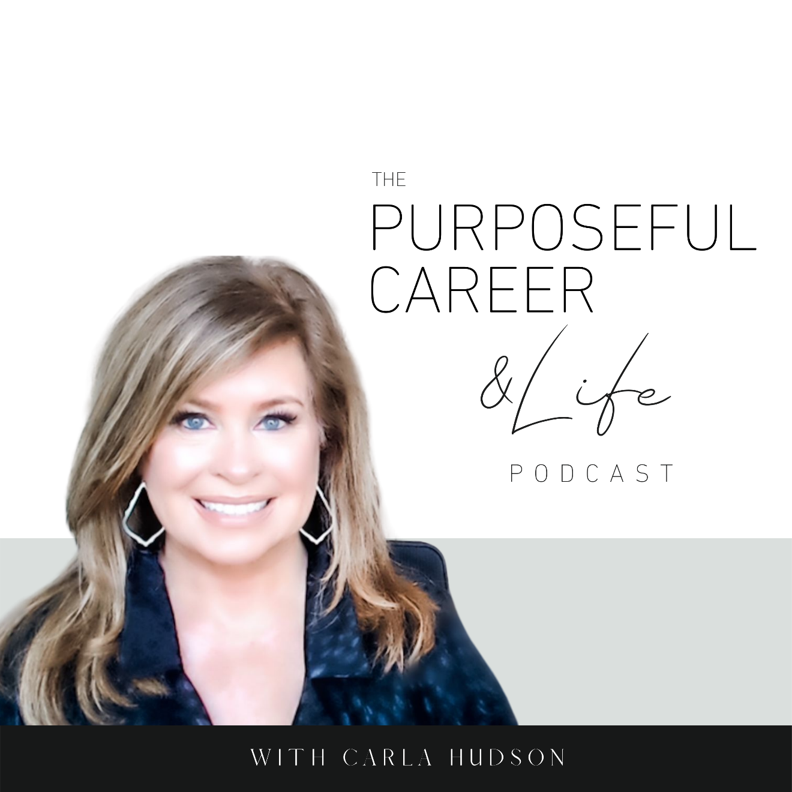

How to Stop Comparing

August 29 2021
Well hello Friends! I hope you guys had an amazing week.
Today I want to talk something how to avoid compare despair.
I thought about this topic because I saw a quote from Teddy Roosevelt this week that said, “comparison is the thief of joy.”
And that made me want to talk about it in this episode because our careers (and our lives for that matter) are full of opportunities to compare ourselves with others.
So, let’s look at where this need to compare comes from. According to psychologists, it gets programmed into us from a very young age.
It might start when we’re young with a parent saying something like, “why can’t you be more like your sister.”
It continues through our school years, with teachers comparing student performance or behavior, like keeping a chart with names and gold stars. Or my personal favorite…my algebra teacher in freshman year who seated us according to how we did on the last test. Low scores in front and high performers in the back row. Math was never my thing so needless to say; I wasn’t sitting in the back row.
It continues throughout our school years as we look to others as a way to measure how WE’RE doing.
And of course, it continues throughout our lives.
Relationships.
Families.
Possessions.
And of course, our careers, as we look to others to measure how WE’RE doing.
Basically, we’ve learned to measure our own performance or value by comparing ourselves to those around us. While some of us rely on comparison more than others, it’s something we all do on occasion.
In psychology, it’s called “social comparison theory.” The theory says that as humans, we’re driven to define ourselves and our value. And one of the ways we do this is by comparing our abilities and achievements to those of other people.
The theory goes on to say that we’re prone to “upward social comparison” when it comes to looking at our own abilities. Which basically means that we compare ourselves to others who are ahead of us, and we use that as a way to measure how we stack up to them.
There’s also something called “downward social comparison” which is when we look to others who are behind us or perhaps in more challenging circumstances. In this case, we look to them because it helps us feel better about ourselves because we think “well, at least I’m better off than that person.”
So, is the habit of comparing ourselves to others a good thing or a bad thing?
Well…the answer is, it depends on our motives for the comparison. And of course, like everything else we talk about on this podcast, I believe the answer is that it can be a VERY good and helpful thing if we use it with purpose and good intention. But it can also be a tool we use to make ourselves wrong or bad or not good enough.
So, let’s look at both forms – the upward and the downward comparison – and how each can be used to either help or harm our self-image.
First let’s look at the positives of upward comparison. I truly believe that this is a very good thing when you use it to inspire yourself.
So, let’s say at work, we have a leader or a colleague who’s more senior that we admire. By examining what you admire about them and comparing that to your own assessment of yourself, you’re able to identify areas that you want to focus on developing. It can help you set goals. Serve as proof to you that what you want IS possible. The net result of this is inspiration and motivation to keep going. So, this type of comparison can be a very HELPFUL tool.
But this upward comparison can work AGAINST YOU if you use this comparison as a weapon against yourself. This happens when we make the comparison, focus solely on where we’re coming up short and then make that mean that we’re a failure or not good enough.
So, the question to ask yourself on upward comparison is, are you using it as a way to beat yourself up and make yourself not good enough? Or, are you using it as a way to inspire yourself to move forward?
When you look at the downward comparison, it also has both a positive and negative side.
From a positive perspective, when we compare ourselves to others whose lives are harder than yours or who might be experiencing a particular challenge, it can help you feel grateful for where your life is and proud of the things you’ve accomplished. It can even help you to really see and acknowledge all of the things you’ve done to get yourself where you are today. And ideally, perhaps it’ll help you develop more empathy for the person who’s having the difficult time and inspire you to reach out to encourage them.
But it can also have a negative effect. When we compare ourselves to others whose lives are harder or experiencing a difficult challenge, it can make us complacent. Like “I’m fine where I’m at.” Or “Well, it could be worse.” And if we’re not careful, this can become a way of getting ourselves stuck.
So, the question to ask yourself here is WHY you’re comparing yourself to others who might be less fortunate. Does this help you feel more grateful for what you DO have and maybe inspire you to reach out with empathy and support? Or are you using this as a way to fuel your complacency and keeping yourself stuck right where you are?
Like everything else in life, it’s about your intent. And unfortunately, since this need to compare is somewhat innate, it’s mostly happening without our conscious awareness. It’s a habitual programmed pattern of behavior for most of us.
The other thing to be aware of is our own state of mental health when it comes to the are of our life that we’re making the comparison. If we’re feeling positive about our life or career and generally have high self-worth and confidence, the compare impulse will likely serve to inspire and move you forward. But if you’re in a more difficult season or struggling in some area, comparing yourself to others can easily drag you down or further damage your self-worth.
And of course, in today’s world, we can’t talk about our human tendency to compare without talking about social media. This whole social media thing has thrown gasoline on the fire of our drive to compare.
Now don’t get me wrong. I’m not hating on social media. I use it, though not as often now as I used to. For me, it became a bit of a time suck and especially with the political environment today, I just decided to stay away for the most part to protect my own peace of mind and to avoid the distraction of getting sucked into it.
While there are of course many positive upsides to social media, it has add a very non-helpful downside when it comes to our tendency to compare in that it’s introduced the addition of illusion. While some of it is real, MUCH of what we see and consume is an illusions.
Images use filters.
Feeds are curated to focus on the carefully selected positives in our life.
So, when we look at those perfect insta lives of others, we’re not only comparing ourselves UPWARDS but we’re comparing ourselves to “an illusion” or a “curated image” that might not be entirely real. After all, few people post all their terrible or sad moments – like the bad hair day or the disastrous date or the holiday spent alone.
Intellectually we all know that no one’s life is perfect, but when we spend hours mindlessly scrolling through the perfection of Instagram, we can easily come away feeling like the world’s biggest under achiever.
And this is not helpful or conducive to positive mental health.
When it comes to social platforms for career, LinkedIn is no different.
Some of my clients tell me they constantly troll the LinkedIn accounts of former colleagues to compare how their own career has kept pace. And when they come up short, they use this as a way to reinforce their own feelings of not measuring up. This can lead to what I call, compare despair. And it can make you feel hopeless.
Of course, there’s nothing wrong with being curious about how former colleagues are doing. And checking in on them online can often bring up good memories of happy times in your career. But when it becomes a tool that you use to make yourself bad, or wrong, or not good enough, it just digs a deeper hole for you to crawl out of.
The problem with social media is really about when most people are using it. Or why. It can become a compulsion. A way to try to escape negative thoughts or feelings about issues in our own lives. And when we go into it with that state of mind, those perfectly curated images make us feel even worse.
So, if all humans are prone to this need to compare, how can we do it in a way that serves us?
Be purposeful in your comparisons.
- Use comparison to gain helpful perspective about yourself, areas you want to develop and the things you aspire to do. And selecting someone ahead of you that you admire and using that as a source of inspiration can really do wonders for your forward progress.
- Remember that what you see on the surface of someone’s life isn’t the whole picture. Even though their life or career might LOOK perfect to you, they have struggles too. So don’t use your observations of their life to convince you that your own life is hopelessly messed up. Super helpful perspective when it comes to social media.
- Practice self-comparison. Comparing NOW you to PAST you can be incredibly helpful when you’re feeling stuck or managing through a disappointment like being passed over for promotion or not getting the job. When you can learn to fully appreciate where you are NOW with where you were as a new college graduate or whatever, it can amaze you. Sure, you may not have gotten that new job you wanted so badly, but 20-year-old you probably never even imaged that you’d be where you are now. This type of comparison is so helpful in building esteem and giving yourself credit for how far you’ve come.
The main thing is to be mindful and aware of when you’re slipping into compare mode.
As we’ve discussed a lot on this podcast, most of the things we think and feel and do, happen subconsciously, the product of programmed thoughts and behaviors. Unfortunately, many times, those programmed patterns don’t serve us. In fact, they hold us back. They keep us from growing and evolving. The solution is to learn how to master your mind by becoming aware of those patterns of thought. If you want to know more about that, go back to episode 1, where we talked about the 5 interrelated parts to any problem.
Be aware of how often you slip into compare mode.
Take note of how it makes you feel.
Do you feel inspired and motivated? Or do you feel hopeless and not good enough?
You can choose to be purposeful in HOW and WHEN and FOR WHAT you use comparison.
Use it as a tool to move you forward. Not as a reason to believe that you’ll never measure up.
And if you ever need a little jolt of positive goodwill toward yourself, practice SELF comparison. Because I can promise you, no matter where you are in life, no matter how many mistakes or challenges or negative things have happened, if you take a moment to think back on YOU at 20 vs. NOW, you will be AMAZED.
In fact, that is my challenge to all of us this week. Take some time to compare NOW you to PAST you. And allow yourself to really appreciate how far you’ve come and everything you’ve been able to achieve. I can promise…it’ll blow your mind.
Even if you’ve been telling yourself you “should be further by now” or “making xx amount of money by now” or “have xx title by now” or “have xx kid by now” or whatever. When you allow yourself to fully appreciate how far you’ve come, how much you’ve learned, how much courage it took you to get where you are, it serves as a powerful proof point for how MUCH MORE you’re capable of achieving in the next 10, 20, 30 years.
Until next time, make it a great week my friends.

