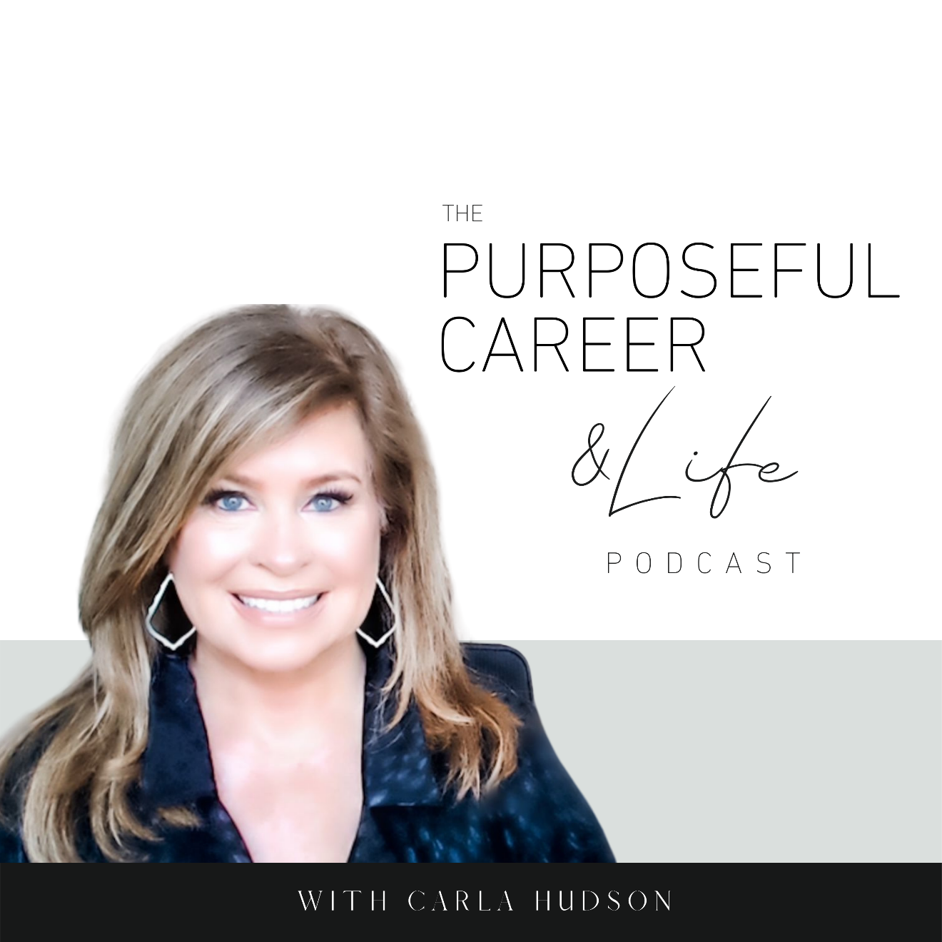

The Top Five Lessons I Learned from My First Year of Podcasting

December 24, 2021
Well hello Friends. I hope you had an amazing week!
In Episode 51, I promised to share a bonus episode with you on the Five Lessons I Learned from My First Year of Podcasting.
I’m ten days late in releasing it so I appreciate your patience and understanding.
While I had the outline ready to record, I actually got a debilitating tooth issue the next day and it took a good week, a round of amoxicillin and an incredibly painful trip to the dentist for me to start feeling good enough to record it. But that’s all a story for another time.
The important thing is that I wanted to share these lessons because I think they will help you. I know they have me.
This podcasting journey began for me on January 1st of 2021. That’s when I had the idea. I knew it was the right next step in my business but I gotta be honest. I wasn’t 100% sure I would a)., actually do it and b). keep doing it once I started.
The whole idea of putting out content into the podcasting universe with my name on it seemed scary and dangerous.
And as a coach, I knew that uncertainty, self-doubt, and fear was coming from my primitive brain. The part of our brain that tries to keep us safe from danger.
But still, it felt like something important. Something I needed to at least try.
So, I had the idea on January 1st and then actually published the first episode on January 3rd. AND, I was going to do it all myself. Research, write, record, edit, and produce.
And on January 1st, I didn’t know how to do any of that.
I decided not to overthink it like I typically would do. Instead, I just made a promise to myself.
I promised myself that I would commit to at least one year and that I would publish a new episode every Sunday.
I chose Sunday even though it’s the lightest listening day for podcasts because most people who are unhappy in their career DREAD Sunday. I know there were many periods in my life when I felt the same. So, I wanted to do something that would give people encouraging, motivational or insightful approaches that they could use to hopefully have a better, happier, more productive work (and life) week ahead.
So, I knew this would be a growth journey for myself. Just learning how to produce a podcast and to do it consistently with quality content was going to be a challenge and I knew I’d learn a lot. But as I began mining my podcasting journey for lessons, I realized it did so much more for myself than I realized.
And I think that’s the beautiful thing about goals.
We make the goal or set the intention because it’s something we care about or want for ourselves. And when we fully commit to doing what it takes to have that new goal, to master it, it always does so much more for ourselves than we expect it to.
And this journey for me is no different. So, I hope you get some insights from these five lessons that you can apply to your own life. Here goes.

Lesson #1: The more you honor your promises, the more you’ll honor your promises.
For me, this one is huge. I made myself that promise on January 1st. And it sounded good, right? But here’s the thing. Every time I set a big goal; I make myself a promise that I’ll follow through on it.
But can I tell you how many times I haven’t done that? So. Many. Times. Not necessarily in my career always, but definitely in my personal life.
The diets. The workouts. Travel to see family and friends. Vacations I said I’d take and then didn’t.
My career and my life are littered with broken promises.
And even though I made the promise to myself regarding this podcast on Jan 1st, I have to tell you, my Inner Critic has wanted me to quit since January 2nd. Even BEFORE I published the first episode.
So many excuses. So much crap I was telling myself about not having time and too hard to grow a podcasting community and I didn’t know how to do all the things to produce a podcast.
And can I tell you how much I hated hearing my own voice at first? And yes, you MUST listen to your own podcast and your own voice when you’re the editors.
It was tough. I wanted to quit. Almost daily in the first few months.
So many times, I just wanted to delete an episode because I didn’t think it was good enough or whatever. But I didn’t. I kept going.
I kept doing the daily self-coaching that I help my clients do. And I persisted.
And somewhere around month five, it started feeling easier. I began to enjoy it more. And I got inspired to plan further out and really got into the episode planning. Even when things got a little crazy in my career, my business, or my life, I kept going.
It became my priority.
And then I realized something else. Suddenly some of those personal things I’d been wanting to do to be healthier like give up caffeine and cut all sugar and flour out of my diet seemed doable. Suddenly they didn’t seem so hard, and I wasn’t tempted to quit like I had before.
And then around month 8, I started to tackle some other things I’d promised myself in the past but kept backing out of, like taking up my writing again. I’ve published two romantic comedies about 5-6 years ago under a pen name and they did well, but I gave it up when my career got a little crazy. Now I’m back in it and loving every minute of it.
So, what I realized is that the promises we make to ourselves are important. They’re not to be taken lightly. We need to take those promises we make to ourselves just as seriously as we might take promises we make to others.
And as you begin to honor even ONE promise and do that consistently, something amazing happens. Suddenly, you realize you CAN honor the commitments you make to yourself, and you’ll start tackling other important things.
So, the more you honor your promises, the more you will honor your promises. And think how that will change your life.
Lesson #2: My SELF judgment is always worse than the judgment of others.
When I first started this podcast, I told myself that part of my fear was coming from what others would think. Or how others would judge me.
But as I began really exploring this fear, I quickly realized something very important. Something that honestly has changed so many other areas of my life for the better.
I realized that I was the one who was judging myself. Me.
Now don’t get me wrong, I knew I had an overactive inner critic. That’s why my business focuses on teaching ways to overcome your inner critic. But I thought my own critic took a very specific form. More along the lines of self-doubt or perfectionism and the ‘who am I to do xyz’. You know…all the imposter syndrome stuff. And sure, I’ve got that in spades.
But it took a lot of self-coaching and inner work to realize that I had a super nasty inner judge. And the things she said to me were mean and cruel and unnecessary. Way meaner than what even the worst internet troll might say.
And when I realized that and I got curious about it, I realized how long that inner judge has been with me. And how much it’s held me back.
As I started to soothe that inner judge and purposefully decided to think kinder more encouraging thoughts, a lot of my desire to quit faded away and the podcast became something I looked forward to.
So, my big lesson here is that quit often, the things we worry about others doing to us – like judgment, criticism, etc., are really the things we do to ourselves. And if you do the inner work to refocus your inner critic into an encouraging inner coach, you can ease that fear and anxiety and you’ll equip yourself to do more of what we talked about in #1 – honor your promises to yourself (and others).
Lesson #3: If you stop telling yourself it’s hard and just start doing it, suddenly it’s not hard.
I’ve been told by many that I’ve got a flair for the dramatic. Hey, as I mentioned earlier, I write romantic comedies as a hobby. So, I do love a good story and turn of phrase.
But I’ve gotta tell you something. You want all out dramatic warfare? Try starting your own service or coaching business.
Drama central. Big time.
Because you’ll have to put yourself and your ideas out there. No hiding. It’s not like my writing career where I could hide behind a pen name. It’s your business.
And when you bootstrap it like I have done, you have to learn all the things.
All the tech, content, creation all of it is going to come from you. And I’ll be honest. In the first few years of this business, I got in my own way a lot by telling myself it was just too hard.
But what this podcasting thing taught me was really important. By deciding on January 1st and starting on January 3rd, there wasn’t a lot of time to overthink it.
I didn’t know how to do any of the things, but I just consulted with Google (my new BFF) and through a little trial and error and about a full day of recording, editing and all the things, I figured out how to do the first one.
And every week, it got a little easier.
So, what I realized after 52 weeks of this is this. Decide what you want to do. And then do it.
Telling yourself it’s too hard is just a self-indulgent and overly dramatic waste of time.
The truth is EVERYTHING is hard until you try it and figure it out. Period.
I’m now applying to other parts of my business. And it’s amazing how much more fun and how much less exhausting life is.
And now, when I feel myself starting to go there with something new, I don’t give the “it’s too hard” thought any airtime. Instead, I just say “let’s get this figured out.”
Lesson #4: It’s perfectly okay to do things imperfectly.
One of the downsides to having spent a lot of your career in brand strategy for big brands is that you have a ton of resources. And you uphold super high standards.
That’s relatively easy to do when you work with the best of the best.
But, when you’re used to having those resources and those high standards and THEN you try to start your own podcast (or business), doing it all yourself, well…it’s not fun.
This is what cranked up the volume on my inner judge that I mentioned in #2.
In producing my podcasts this year, I experience all the things.
Editing glitches.
My cat scratching at the door to get in while recording.
The lawn guy showing up Every. Single. Time. I was recording. No matter what day by the way. I swear he somehow knew when I was recording. Hahaha
The airplane flying overhead.
And I would just cringe when I heard that in the final piece.
But then I realized something else.
Who cares?
The point of this is not to be perfect. It’s to share important information that I think can help others in some way. And when I started focusing on that, I stopped focusing on those imperfections.
This really came home for me one day when I was listening to one of my mentor’s Brooke Castillo, and she was recording her podcast that week while driving. So, she caveated that the sounded would be a little different or whatever. But I realized, that didn’t matter. What mattered was what she shared. And that she DID share.
That was huge for me. And it helped me stopped listening to my inner judge.
Sure, my dream someday is to have someone do the editing for me. But until that happens, I’m just focused on trying to do better each week. (Well, that and keeping my cat in another room on the other side of the house…lol).
Lesson #5: Trust yourself.
The last lesson I’ll share is kind of related to #1 and that is to Trust Yourself.
Here’s what I mean. Trust that you set the goals you set because they’re important to you.
You want it.
And you want it for a reason, otherwise you wouldn’t want it.
So, you owe it to yourself to trust that.
And when you trust yourself – when you trust that the things you want are there because they’re meant to be an important part of your journey or your contribution or whatever – you’ll honor them.
I think that’s why I’ve quit on so many things in my past.
I wasn’t trusting that the things I wanted – no matter how big or small they were – were important. So, when I believed that – that the thing I wanted didn’t matter or wasn’t important or that it was only FOR ME – it was super easy to quit.
After all, it didn’t matter, right?
And what I learned from 52 weeks of podcasting is that there were lots of ways – most of them unexpected – that I benefited from the consistency. Most of them unexpected.
I learned to trust myself – this podcast was important to me, and my business and I honored that.
And that helped me trust myself even more in other areas.
Saying no to a few unexpected corporate jobs that came to me out of the blue this year. Even though they were great roles and more money and all the things, they would’ve taken away from my time on the business. So, I trusted myself to say no.
Trusting myself to choose the best concepts or topics to help my listeners.
Trusting myself as a coach and teacher.
It’s kinda like I said in #1. The more you trust yourself the more you will trust yourself.
And I think that’s where it all starts. With deep and unending self-belief. Even when you don’t know how to do it. Even when it might get hard. Even when your inner judge or critic flares up. Even when it’s not perfect. Even when you’re tempted to quit.
So, to recap the five big lessons:
- The more you honor your promises, the more you’ll honor your promises.
- Self-judgment is always worse than the judgement or others.
- If you stop telling yourself it’s hard and just do it, suddenly it’s not hard.
- It’s perfectly okay to do things imperfectly.
- Trust yourself.
As a reminder, if you’re thinking about some big goals of your own for 2022, sign up for our FREE workshop called Goal Getter. You can sign up by going to thepurposefulcareer.com/goalgetter for more details.
Wishing everyone a beautiful Christmas with all the people you love.
Until next time, make it a great week my friends.

