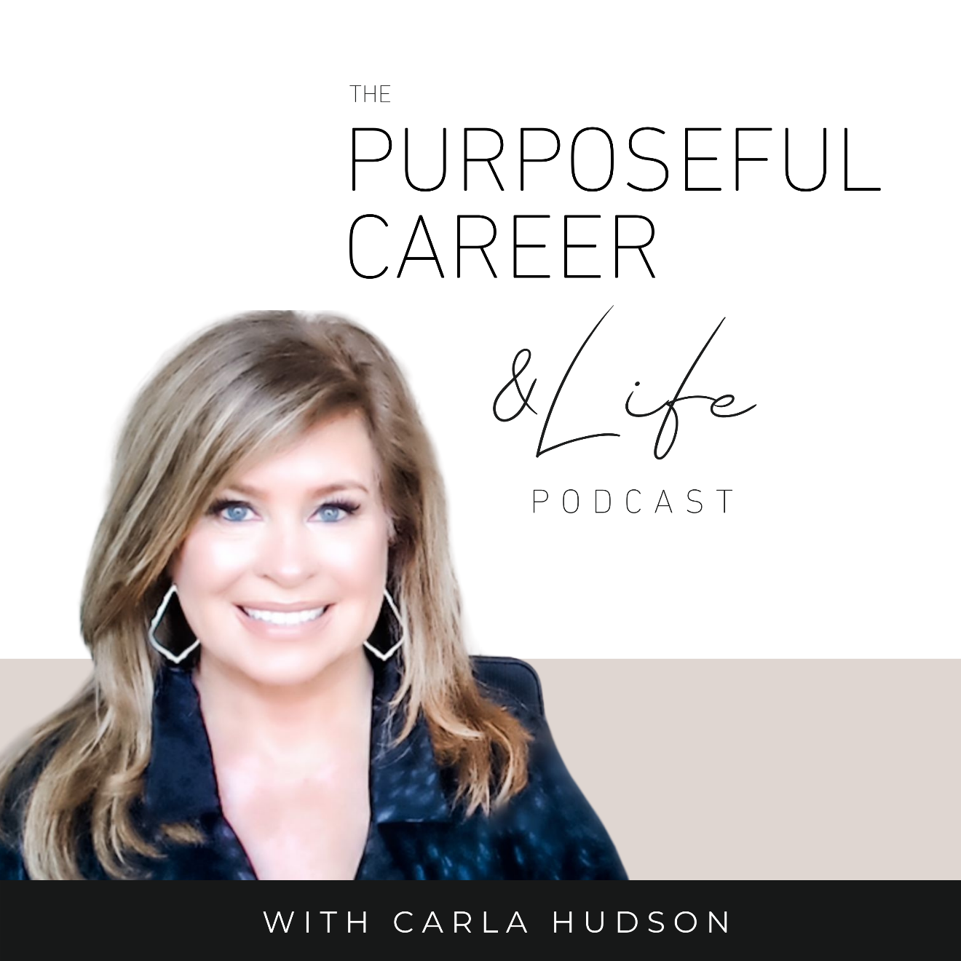

Learning the Lessons from 2021

December 26, 2021
Well hello Friends!
I hope you had a wonderful Christmas celebration filled with everything and everyone you love.
I visited family earlier this month, so this year I stayed in Dallas. And my day was super relaxing. Filled with a little football, a little Netflix-ing and some good food.
It was a sunny 80-degree day here in Dallas and for a Midwest girl, it’s kinda hard to get used to that at the end of December. Even after 7 years, it just feels…not right. I think next year, I’m gonna have to spend it somewhere wintry. Just so I can have the fireplace going and the snow outside and get to wear all the sweaters and the outerwear. You know?
BTW if you would’ve told me in the winter of 2014 that I would miss snowy weather, I never would’ve believed you. That year in Chicago it snowed 100 inches from November to April. I thought I’d never be warm again. And when I got the job in Dallas, I gave away all my sweaters and coats and got here as fast as I could.
So…just goes to show what a little distance and perspective will do for you, right? lol
And that’s what we’re going to talk about today.
Perspective on your 2021. Because it’s the last week of the year. Can you even believe it? Crazy.
And when we get to this point in the year, most of us naturally spend a little time looking back and reflecting on the year that was. At all the experiences, the achievements, the failures, the losses, the disappointments.
All of it.
But the question is, what do we do with that information?
Are we just reflecting on our experiences in a passive way?
Or, are we taking everything we learned from those experiences and using that to make 2022 even better?
In my experience, most of us just reflect and move on.
We kind of summarize the year into a big generalization that captures our experience overall – the combination of all the good, the bad, the challenging – as either being ‘a good year’ or ‘a bad year’ or ‘a challenging year’ or whatever.
If you doubt this, just go back to 2020.
Looking back. How do you think about that year?
Most of us would say it was tough. Transitional. Isolating. Worrying. Uncertain. And that was true for most of us around the world.
But those who look deeper, who took the time to mine their experiences for lessons learned might say it was transformational. Life changing. Clarifying. Because they took the time to look at the experiences – the good and the bad – to identify the lessons.
Because the truth is, the value of the experiences we have is not just the having of them. It’s what they can teach us if we take the time to look at them.
The point I want to make is that, as humans, most of us tend to reflect on our year in a more general way or maybe not at all.
And as part of that, we lump all the experiences of the year together and come away with a generalization, a vibe or mood, that we then label as either good or bad.
By labeling the year, we give ourselves a way to think about the year that’s now in the rear-view mirror and what it meant in our lives.
I’ve done the same thing.
As an example, I recently was reflecting on my life as part of some journaling I was doing. I was looking at all the big moments I could recall from each decade – good and bad. And as I glanced through the list, I very quickly labeled the last decade “the most challenging decade” of my life. And I remember saying to myself: I don’t ever want to repeat it again. EVER.
And after some reflection, I would say this is still true.
It’s a decade that I’m personally glad is in the rearview mirror for so many reasons. It started challenging and it ended equally challenging.
And yet, as I reflected more, I realized…if I left just left my takeaway there – if I just skate across the top of my experiences from that decade and just generalize it as ‘the most challenging of my life” then what was the point of going through all the things? Because isn’t the point of having all the good and bad experiences to TEACH us important things?
If I just STOP there…at the categorization of the last decade as being ‘the most challenging of my life’, I’m missing what I think is the entire point of the time we spend on earth. And that is, what does that “most challenging decade of my life” have to teach me…
About me.
About my decisions.
About what I want.
About what I don’t want anymore.
About the person I’ve become through those experiences.
After I did this reflection in more detail, the lessons I learned were incredibly valuable. And now I give that decade a different label. I call it ‘the most important decade of my life.” At least so far.
That is gold. And it’s the stuff we don’t often think about.
But if we DO…the answers to those questions will provide invaluable information that can help improve everything about your life going forward.
That said, if you don’t actively seek out the answers to those questions, you’ll never learn the lessons. Not all of them anyway. Because it takes reflection and exploration to really find all the lessons, big and small.
And those lessons go far beyond the skills we learned. They include things like how they’ve further shaped your values. How they’ve informed what you want from life and your career going forward.
Even more, if we don’t take the time to learn from them – especially the challenges or the mistakes or the times we messed up a little - I think we’re doomed to just have the same unsatisfying or challenging experiences again and again and again.
After all, as Pema Chodron says, “Nothing ever goes away until it has taught us what we need to know.”
And with one week left in the year, there’s no better time to do this reflection. That’s why, today we’re going to talk about mining for the lessons.
So, let’s dive in.
The first thing to know is that our brains like to categorize things. They like to make sense of the world by placing a label on things. That helps us understand the things that happen to us and to frame them in a way that we think makes sense. Either good or bad.
That’s part of our primitive brain, the part in the back near the brainstem. And it’s the part that’s evolved over the Millenia. This need to categorize or label things helped our caveman ancestors who’s world was simpler and more extreme. For them it was about survival. And that’s it. So, the primitive brain’s ability to categorize helped them avoid danger and stay safe so they could survive.
The primitive brain is the part of our brain that’s reactionary. It’s not the part about proactive thought.
And as we talk about a lot on this podcast, it’s easy to just let that part of our brain run the show. After all, the categorization will make sense to us.
As in the example I shared about myself, that original label as “the most challenging” is still true for me if I just look at it simplistically. And if I shared all the big good and bad moments with you, I think you’d probably agree with that.
BUT, when I took the time to reflect MORE and mined for all the lessons those Big Moments had to teach me, NOW I have a label that I think is ever truer. And that is, I now see that action-packed decade as the most IMPORTANT so far.
We don’t want to just look back on our career or life in a simplistic way. To just accept the label our brain will assign to the year or the month or the week or the day, and then file it away and move on.
I mean, that’s what they tell us right? Just let go.
And we DO need to let go of many things.
But I would say only letting go of the aspects of the things that happened that don’t serve us. Or maybe letting go of the simplistic label.
After all, when you take the time to really examine your most crushing disappointment or your most triumphant achievement, you’re going to come up with lots of incredibly valuable things that you learned – about yourself, about your values, about what you want and don’t want, about what you’ll do differently next time – because you went through it.
So as 2021 ends, we want to mine all the big moments of the year for everything they can teach you. And that will allow you to bring all that insight and wisdom into your next attempt.
So, in your career or life, if you feel like you’re on this never-ending cycle of having the same experiences again and again and again, it’s probably because you haven’t really learned the lessons your earlier experiences have to teach you and incorporated them into your approach moving forward.
At the heart of this approach is something called “benefit finding”. It’s a way of viewing an experience – whether positive or negative – through the lens of personal growth.
When we learn how to look past the achievement or the disappointment or the loss, to instead focus on what we learned by experiencing it, we can get more direction and meaning in our career and lives.
We also start to build a growth mindset, which is at the heart of personal improvement because people that have a growth mindset tend to view failure as an opportunity to learn and grow rather than as a judgment about themselves.
Beyond that, this process of benefit-finding will help you understand past experiences at a deeper level. And it’ll help you shape your approach to future experiences with the valuable lessons you’ve learned by having gone through it.
So, let’s do the exercise that I call, My Learnings List.
You might want to take out a pen and paper or open a Google doc.
Now, my intention was for you to look back at 2021 in your career or business and use that as the lens for this exercise.
But this doesn’t have to be just a once-a-year thing. You can also do the same thing on a more regular basis like at the end of a work week or work month. And if you want, you can also use the same approach for your personal life.
It’s totally up to you how you use it. But once you do, I know you’ll see the value of it.

#1. List your big moments from the past year
For this, I want you to think back through 2021 and write down all the big things that happened to you. And be 360 with it. Meaning be sure to include ALL the things. Good, bad, challenging, sad, disappointing, embarrassing, whatever.
This is not just a celebration of achievements. This is about mining for the deeper lessons that each experience can teach you.

#2. Look for the lessons
Now, for each of the big moments you listed in #1, I want you to answer four questions.
So, this exercise will take you some time, but it’s worth it. Because you’ll be fully exploring each of your big moments, so you find the lessons each can teach you.
You’ll notice these are big open-ended questions. And that’s for a reason. There’s value in getting it all down on paper where you can see it, instead of leaving it in your head where it’ll just swirl and fester.
All right. Now, just choose your first big moment from #1 that you want to focus on, write that at the top of the page and then answer these four questions. And when you answer, spend the time so you fully explore each. The more you work at this, the better your takeaway will be.
- List at least two things this experience has taught you about yourself.
- What has it taught you about what you do want or no longer want for yourself?
- What are some positive things that came from this experience?
- In what ways did the experience help you grow as a person?

#3. Identify what you will do going forward
Now we’re going to look at what you learned from these big moments that will change what you do or how you do it in the future. There are three questions:
- If this experience were to happen again, what could you do to make the most of it?
- In what ways has this experience prepared you to face similar things in the future?
- If you do find yourself in a similar situation in the future, what would you do differently?

So, remember, just take each of your big moments and answer the questions I shared in #2 and #3. If it feels too big to tackle all your big moments, just limit your list to five of the ones you think are most important or impactful.
When you do this, you’ll realize that the things you learned this year have changed you. You know more. You’ll be clearer about what you want. What you’ll tolerate. What you won’t. What you’d do again. What you’d do differently. And most importantly, why.
So much better than just assigning 2021 a simple label. This exercise will give it meaning. And it might even change your mind about who you are, what you’re good at and what you want from your career and life moving forward.
And that’s what I wish for all of you.
On Friday of this week – New Year’s Eve – I’m going to release a bonus episode called “Starting Strong.” So be sure to give that a listen. It’ll help you get a jump start on everything you want to achieve in 2022.
And if you haven’t done so already, be sure to sign up for our FREE workshop in early January called Goal Getter. You can do that by going to thepurposefulcareer.com/goalgetter.
Until next time, make it a great week my friends.

