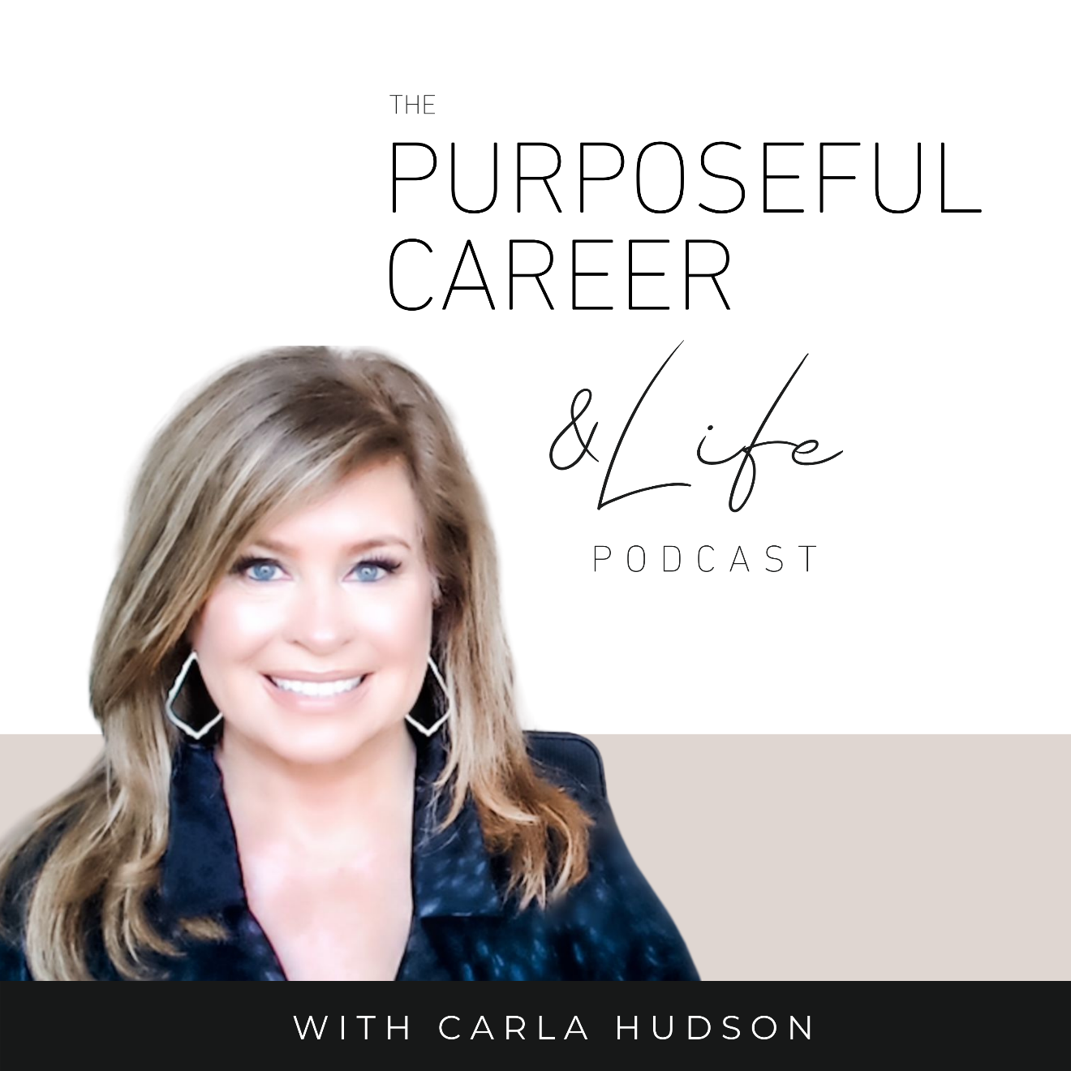

Starting Strong

December 31, 2021
Well hello Friends!
I hope you guys had an amazing week!
In the last episode, we talked about the value of looking back on the year that was so we can harvest all the lessons you learned this past year.
What you learned from your successes, your failures, your wins, your losses.
Because all of it has something valuable to teach us, right? And this is the ideal time of year to do that.
So, if you haven’t listened to last week’s episode called “My Learnings List”, I invite you to go back and do that.
In it, I share some thoughts on how to think about those lessons and I walk you through a super helpful exercise. This is a great way to make sure that you capture all that hard-earned wisdom and bring it with you going forward.
But today, I want to shift your focus to the future.
Because it’s New Year’s Eve. The last day of 2021!
And that means that we’re just a few short hours from a bright shiny new year.
I just love the whole clean slate thing. The idea that there’s 365 blank pages in the book of 2022. And YOU get to decide what you want to fill those pages with.
What you’ll invest your time in.
Who you want to be.
What you want to learn.
What you want to experience.
But today we’re not going to talk setting goals. We’ll do that on Sunday (in the next episode).
TODAY we’re going to talk about how to get yourself READY to set big life changing goals. Because that’s what I want to invite you to do this year.
Allow yourself to dream big.
Allow yourself to imagine that 2022 is the year you don’t just make small steps forward, but you make a giant leap forward. Maybe a leap that even scares you a little because it feels so big and impossible.
And if that’s the kind of life changing year we want to have, it’s not as simple as jotting down some goals in like 15 minutes.
Big dreams require big mindset preparation. You need to be very purposeful in how you’re thinking about the goals you select. I think of these as filters or the lens that you view the goal through. And there are three of them.
They are:
#1. Be future focused
#2. No limits or boundaries
#3. Believe it is possible for you
So, let’s explore each of these filters in a bit more depth.

#1. Make your goals from a place that is future focused.
Many times, we look at our life as it is today and then set goals to course correct or build from where we are to a place that’s incrementally better.
Losing weight is a great example of this. We don’t like what we weigh so we set a goal to lost weight.
So is paying off the debt.
Or finding a new job.
There’s nothing wrong with any of those goals but they are all coming from a past focus.
They’re coming from a place where we have a result we don’t really want and so we focus on starting at that place we don’t want and then course correcting from there.
And while it’s natural for some of your goals to be about that, the truth is that if we want 2022 to be a year when you moved ahead in a really big way, you’ll need to do at least some of your goal setting from a future focus.
This means you’re dreaming of future possibilities without being grounded to or tethered in the past (i.e., where you are now).
For this, here are some great questions to ask yourself.
What do you want to do with your career or life in 2022?
Notice how different that is vs. the past-focused examples we discussed earlier on losing weight or paying off debt. What do you want to do with your career in 2022 is purely blank page dreaming? It’s not limited in any way by where you might happen to be now.
Or if you want to set a financial goal it could be: What do you want to earn in 2022?
Notice how it’s not tied to anything that might exist now. It’s not using your existing income as the basis for your future possible income.
Another question would be: Who do you want to be in 2022?
These big open ended and future-focused questions can lay the foundation to a transformational year.

#2. Don’t encumber with limitations or boundaries.
Don’t put arbitrary limits or boundaries on what you want.
This is what we tend to do as adults. We tell ourselves we want to be realistic. So, we set limits on the things we want so they seem more doable.
But if you want to make really big changes, it’s helpful to set big goals. And then allow yourself to see what you can create or bring into reality as you go after them.
I think we set boundaries or limitations to protect ourselves from disappointment or the fear of failure.
But the purpose of having a goal is about aiming for a desired result. About really reaching to see what we can make happen.
Trying to decide that answer in advance doesn’t make sense. It keeps our possibilities smaller than they should be because we don’t allow ourselves to really aim as high as we might want.
So, if you want something big and next level in 2022, don’t decide in advance by setting arbitrary limits or boundaries. Just set the goal, however big or impossible it may seem, then go after it. And let your own efforts find where the limit is for you.
Imagine how much further you can get with an approach like that.

#3. Believe it (or anything really) is possible for you.
Lastly, you must believe it is possible for you.
As adults, most of us have a healthy “reality filter” of what we think is possible for us. And we believe this filter is true.
But really, it’s just a story we make up about what’s possible based on biases, judgments, and fears. It usually comes from a combination of things people have said to us, things we’ve experienced or saw and then we’ve made those things mean something about us or our ability to go after new big things.
This story helps to protect us from the possible danger of putting ourselves out there and maybe failing or being judged.
Believing that anything is possible for you requires disciplined thought.
It’s about having faith in yourself and in your ability to make anything happen even when you have no proof that it’s possible.
And if you want to have a life-altering 2022, you need to believe that the big bold goals you set for yourself are possible. Otherwise, you’ll start talking yourself out of having the thing before you even get started.

For most of us, none of these three things – being future focused, no limits or boundaries and believing it’s possible – will feel natural.
They’ll all feel risky.
And they’ll push against our natural desire to want to feel safe and in control. They all require belief in yourself and in your ability to go after and master new things you’ve never done before.
As we go into a brand new year, let yourself imagine all the new possibilities available to you. Because that’s what you deserve.
Until next time, make it a great week my friends.

