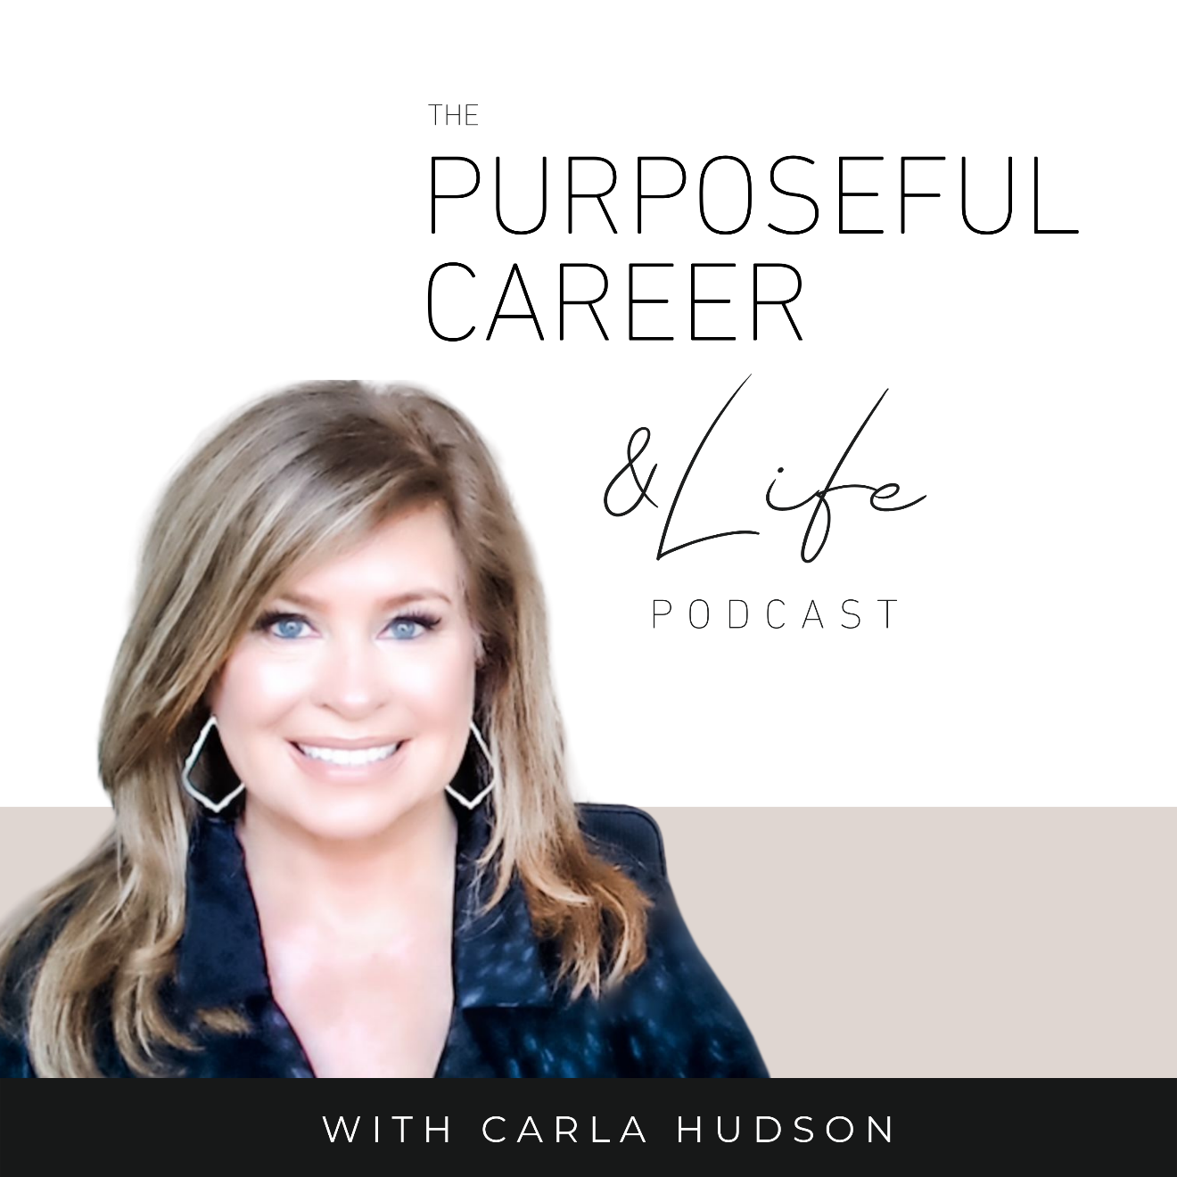

One Big Crazy Goal

December 2, 2022
Well hello Friends!
I hope you guys had an amazing week!
A few days ago, I shared a bonus episode called Starting Strong.
And in that, I shared three filters to keep in mind when choosing your goals for the year. So, if you haven’t had a chance to check it out, do go back and give the episode a listen. Because it’ll be super helpful context for what we’re discussing today which is “One Big Impossible Goal.”
A few years ago, my thinking around goals changed.
You see, in the past, I mostly based my annual goals on where I was in that moment. And mostly, if I’m being honest, they were about fixing or next leveling something about myself or my life that I wasn’t entirely satisfied with. So, it was the usual stuff like eating healthier or making more money or finding the next level job or whatever.
On the one hand, that made sense because it was kind of like giving myself an annual tune-up. I mean, nothing wrong with doing a little course correction, right?
And that’s probably true so long as that’s not ALL you’re doing. If those little course corrections are just part of the goals picture for the year, then using some of your effort to make strategic adjustments to certain aspects of your career or life makes total sense.
But here’s the thing.
If you approach ALL your annual goals like that, it’s limiting. Because that means you’re basing everything on your present self. On results you already have that you now want to tweak.
That’s why I say it’s limiting. Because it’s only focused on the parameters of where your life is right now. If you base your future goals solely on where you are…then that means your future can only be a slightly better version of where or who you currently are.
And while that sounds fine at first glance, the downside is that it means that everything that isn’t in your life right now – anything completely new or transformative – is off the table.
And since this is the start of a brand-new year, I think it’s worth asking yourself an important question: Why settle for a tweak when you can transform?
I know transform sounds like a big scary word. But it doesn’t have to be.
We’ve all transformed a lot throughout our lives. We’ve learned new, life changing things like how to walk when we were a toddler. Or how to read and write in elementary school. How to drive a car when we turned 16. How to be a parent when we have kids. How to master a new job skill.
But somewhere along the line as we get past early adulthood things change. At least for most of us.
It’s like once we’re out of school and we settle on a path – the job, the relationship, the kids, the city, the friends – we start to settle into those boundaries.
I think most of the time we don’t even think about it. Or realize it. It just happens.
Life gets comfortable. WE get comfortable. And we start to think of the collective of all those things – the job, relationship, kids, city, friends – as our life.
And then when we set goals, mostly it’s based on our present self. So, the boundaries that we drew for ourselves, we stay within, and we settle for goals that try to sort of optimize us inside those boundaries.
But what if we didn’t?
What if we held on to all the things that we love but we allowed ourselves to re-imagine some part of our life. To maybe pursue a dream that we’ve had for as long as we can remember but haven’t let ourselves think about for more years than we can count.
Maybe because we told ourselves it was too late.
Or we were too old.
Or it’s too hard.
Or you don’t have the right education.
Or it’s impossible.
Or whatever you’ve been telling yourself.
What if you decided to choose One Big Crazy Goal for 2022? And what if you went all in on it?
What if you turned off the inner critic and all those “too’s” and “should’s” and “can’ts” it tries so hard to convince you is true and you just decided to do it?
What if you approached that One Big Crazy Goal for 2022 without all the drama and fear? And you chunked it down into small simple steps and just went for it?
Imagine what it would do for your confidence.
How it would improve your life.
Your relationships.
Your satisfaction.
Maybe your finances, depending on what it is.
And as you made progress against that One Big Crazy Goal, what else do you think it would inspire you to do?
All kinds of things big and small probably. Maybe you’ll finally master all those smaller, tweaking goals that perhaps before, you would give up on a month or so in.
But something happens when we take on A Big Crazy Dream. Suddenly, all those things that used to seem so hard now seem so much easier because you’ve proven to yourself that you CAN do hard things.
I think as adults, many of us stop dreaming. We have some disappointments in our career or life, and we just settle for what we’re got, and we try to make the most of that.
For some of us, we’ve gotten so used to living this way that we’ve lost touch with the things we really want. Once that inner voice is ignored for a while, it stops trying to get us to listen. Because it assumes we never are going to listen.
But I’m here to tell you it’s never too late to reignite that dream.
Whether you want to change jobs, get promoted, start a business, or maybe finally write that book or go back to school. Whatever it is for you, it’s not too late.
And RIGHT NOW, is the perfect time. It’s January 2nd. The start of a new year. Let this be the year you FINALLY go for it.
Now, assuming a good number of you might not know exactly what you want your One Big Impossible Goal to be. So, I’m going to walk you through a simple exercise. At the heart of this exercise is a question that one of my coaching mentors, Jody Moore, uses and I think it is so awesome.
I LOVE it because it does what all good coaching should do. It cuts through all the clutter and the fluff and the distraction and it gets right to the heart of what you care about most.

One Big Impossible Goal Exercise
So, for this, take out a pen and paper or open a google doc. And answer this question.
As you do this, keep in mind the three filters, I shared in the last episode.
Keep the goal future focused. Meaning, not limited by where you are today.
Don’t set limits or boundaries on it. Let it be big and bold and scary.
Believe that it’s possible. Even if it sounds a little crazy at first.

Here goes:
- What do I really really really really really really really want?
Now, each of these ‘reallys’ is important because if you’re going to set one big crazy goal, it needs to be something you’re passionate about. And we’re going to cast the net broadly. We’re going to write down one thing you want most under each of these five categories.
- In my career

- In my relationships

- In my health

- In my finances

- In my life

- Of my answers, which do I want the most? This is your One Big Crazy Goal.
Now, from the answers you wrote above, choose the ONE that you’re most passionate about. And again, don’t discount it because it might seem crazy or impossible. That’s the entire point. This is the year; we’re going to let ourselves dream. Let ourselves go for it. So, choose the one you want most. Not the one you think is most doable.

- Who do I need to be to create this result?
Now, this is something you’ll be working on the entire year. Because in order to achieve something big, bold and crazy, you’re going to have to become the next level version of yourself. You’ll need to do the thought work. You’ll need to stop listening to your Inner Critic who’s going to try to convince you to quit and start listening to your Inner Coach. You’re going to have to have the grit and the determination and the persistence to stay with it even when it gets hard. Even when you might stumble.

And you’ll start where every goal starts. You’ll have a plan, chunk it down and start moving, one small step at a time.
Only this time, you’ll have the determination to stay with it.
To persevere.
And to never EVER quit on yourself.
If you want a little help as you take this on, go to thepurposefulcareer.com/nextlevel. Doors open soon and that’s the place where you’ll do all the inner thought work that it’ll take to turn your heart’s desire into reality.
Imagine the possibilities for your life. And then, go make it happen.
Until next time, make it a great week my friends.

